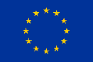

This project has received funding from the European Union's Horizon 2020 research and innovation programme under the grant agreement No. 101037141. This material reflect only the views of the Consortium, and the EC cannot be held responsible for any use that may be made of the information in it.

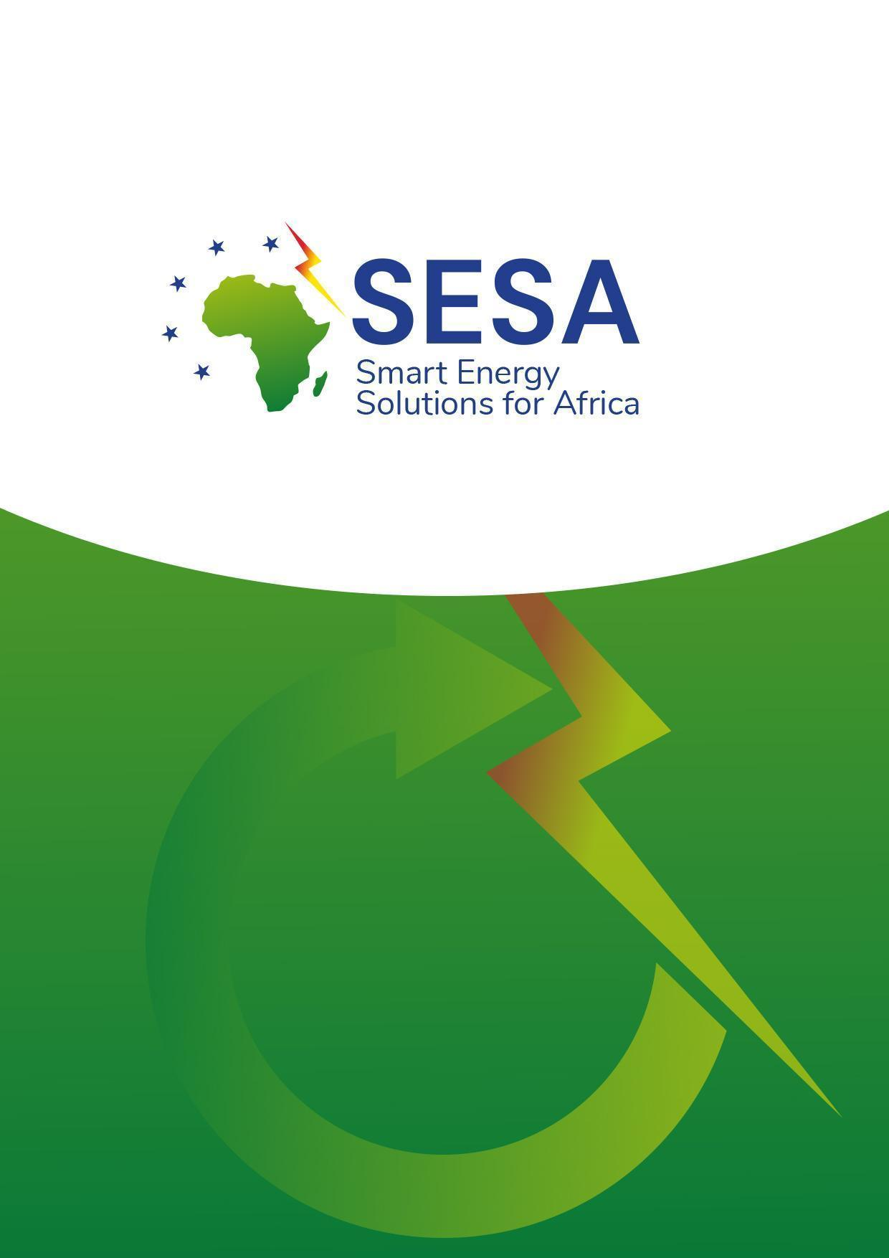
SESA Capacity Building Plan
Version 2
22/07/2022

Summary Sheet

Deliverable Number | 2.1
Deliverable Title | Capacity Building Plan
Full Project Name | Smart Energy Solutions for Africa (SESA)
Responsible Author(s) | Claudia Schroder, Erin Hill, Christelle Beyers (ICLEI Africa)
Contributing Partner(s)
Reviewer(s) | Giorgia Rambelli, Silvia Assalini
Contractual Delivery Date | 31 March 2022
Actual Delivery Date | July 2022
Status | Draft second version
Dissemination level | Public
Version | 2
Document ID | D2.1

Legal Disclaimer
SESA (Grant Agreement No 101037141) is an Innovation Action project funded by the EU Framework Programme Horizon 2020. This document contains information about SESA core activities, findings, and outcomes. The content of this publication is the sole responsibility of the SESA consortium and cannot be considered to reflect the views of the European Commission.

Table of contents
Summary Sheet 2
Legal Disclaimer 2
Table of contents 3
1. Introduction 5
About SESA 5
2. Methodology 6
2.1. Desktop research 7
2.2. Engagements with Living Labs 7
2.3. Semi-structured interviews and questionnaires 7
2.4. Focus group/kick-off workshop 7
2.5. Ethical considerations 8
2.6. Limitations 8
3. Capacity and skill needs assessments 8
3.1. Kenya 9
3.1.1. Country context and background 9
3.1.2. Actions planned for Living Labs in Kenya 10
3.1.3. Present and future capacity on sustainable energy development 11
3.1.3.1. Political and legal capacity 12
3.1.3.2. Economic and social capacity 20
3.1.4. Gaps between present capacity and future desired skills 20
3.1.4.1. Political and legal capacity gaps 20
3.1.4.2. Economic and social capacity gaps 21
3.1.5. Tools to fill capacity gaps 21
3.1.6. Summary of results 22
3.2. Malawi 26
3.2.1. Country context and background 26
3.2.2. Actions planned for Living Lab in Malawi 26
3.2.3. Present and future capacity on Sustainable Energy Development 27
3.2.3.1. Political and legal capacity 27
3.2.3.2 Economic and social capacity 29
3.2.4. Gaps between present capacity and future desired skills 29
3.2.4.1. Political and legal capacity gaps 29
3.2.4.2. Economic and social capacity gaps 30
3.2.5. Tools and trainings to fill capacity gaps 30
3.2.6. Summary of results 31
3.3. Ghana 33
3.3.1. Country context and background 33
3.3.2 Actions planned for Living Lab 33
3.3.3. Present and future capacity on Sustainable Energy Development 34
3.3.3.1. Political and legal capacity 34
3.3.3.2. Economic and social capacity 36
3.3.4. Gaps between present capacity and future desired skills 36
3.3.4.1. Political and legal capacity gaps 36
3.3.4.2. Economic and social capacity gaps 37
3.3.5. Tools to fill the capacity gaps 37
3.3.6. Summary of results 38
3.4. South Africa 41
3.4.1 Country context and background 41
3.4.2. Actions planned for the Living Lab 41
3.4.3. Present and future capacity for Sustainable Energy Development 42
3.4.3.1. Political and legal capacity 42
3.4.3.2. Economic and social capacity 43
3.4.4. Gaps between present capacity and future desired skills 44
3.4.4.1. Political and legal capacity gaps 44
3.4.4.2. Economic and social capacity gaps 44
3.4.5. Tools to fill capacity gaps 44
3.4.6. Summary of results 46
3.5. Morocco 49
3.5.1. Country context and background 49
3.5.2. Actions planned for Living Lab 49
3.5.3. Present and future capacity on Sustainable Energy Development 51
3.5.3.1. Political and legal capacity 51
3.5.3.2. Economic and social capacity 53
3.5.4. Gaps between present capacity and future desired skills 54
3.5.4.1. Political and legal capacity gaps 54
3.5.4.2. Economic and social capacity gaps 54
3.5.5. Tools to fill capacity gaps 55
3.5.6. Summary of results 56
4. Summary of capacity-building tools 60
5. Conclusion and recommendations 76
Reference list 77

1. Introduction
The Capacity Building Plan, developed through the Smart Energy Solutions for Africa (SESA) project, intends to assist the SESA project, its partners and the local communities engaged in strategically identifying capacity and skills development topics, methods and tools to support a further uptake of sustainable energy use in selected urban and rural areas in Africa known as “Living Laboratories” (“Living Labs” in short). The Living Labs are real-life test beds for innovative energy solutions, enabling the project to experiment in different environments. The urban and rural areas under discussion are as follows: Kisumu and Homa Bay, Kenya (Demonstration Living Lab); Ga North Municipal District and Atwima Nwabiagya Municipality District, Ghana (Validation Living Lab); Alicedale, South Africa (Validation Living Lab); Waliranji-Mchinji, Malawi (Validation Living Lab) and lastly, Marrakech, Morocco (Validation Living Lab).
The Capacity Building Plan is informed by comprehensive capacity and skill needs assessments on energy use undertaken in the five Living Lab countries mentioned above. The needs assessments for Ghana, Kenya, Malawi, Morocco and South Africa will use qualitative research methods to 1) assess the present capacity of local innovators and authorities on Sustainable Energy Development, 2) understand the future capacity (desired state) based on the city’s vision for the Sustainable Energy Use, 3) identify gaps between present capacity and future desired skills, and 4) select tools and training modules to fill these gaps.
This Capacity Building Plan consists of five chapters. Chapter 1 presents an overview of the Capacity Building Plan and its position. Chapter 2 describes the methodology used to develop the capacity and skill needs assessment and, therefore, the Capacity Building Plan, including the research methods, ethical considerations and limitations. The capacity and skills follow this needs assessment for Kenya, Malawi, Ghana, Morocco and South Africa in Chapter 3. The capacity and skill needs assessments for each country in Chapter 3 detail the following: an overview of the country's context and background; SESA’s Living Lab project sites in the country; the country's energy governance structure; the various policies, plans and strategies that are relevant to the country’s energy landscape; the present capacity of local innovators and authorities on sustainable energy development; the future capacity (desired state) based on the Living Lab’s city vision for the sustainable energy use; the gaps between present capacity and future desired skills identified and; the relevant tools and training modules to fill the gaps. Chapter 4 outlines the next steps to be undertaken for the Capacity Building Plan, as well as the timelines for these steps. The concluding remarks, together with some recommendations are provided in Chapter 5.

About SESA
SESA is a collaborative project between the European Union and nine African countries (Kenya, Ghana, Namibia, Malawi, Morocco, South Africa, Nigeria, Rwanda and Tanzania) that aims to provide energy access technologies and business models that are easily replicable and generate local opportunities for economic development and social cohesion in Africa. Through several local Living Labs, the project is expected to facilitate the co-development of scalable and replicable energy access innovations, to be tested, validated, and later replicated throughout the African continent. These solutions will include decentralised renewables (solar photovoltaics), innovative energy storage systems including the use of second-life electric vehicle batteries, smart microgrids, waste-to-energy systems (biomass to biogas), climate-proofing, resilience and adaptation, and rural internet access.

Running from October 2021 until September 2025, SESA is the result of a strong partnership between leading European and African universities, research centres, industry actors, local governments, knowledge and implementation organisations and networks. These will be strengthened via peer-to-peer exchange, policy dialogues, and regional and international events, among others.

2. Methodology
Four primary methods were used to determine the current capacity and needs in the urban and rural sites selected and, thus, inform the Capacity Building Plan. These four methods include 1) desktop research of existing documents for the various Living Lab sites, 2) virtual engagements with the Living Lab implementation teams, 3) in-depth, semi-structured interviews with selected stakeholders in the various Living Lab sites, and 4) a focus group discussion with all the Living Lab's stakeholders to reflect on the findings obtained during the interviews. This chapter provides a detailed description of these methods and the limitations experienced along the way.

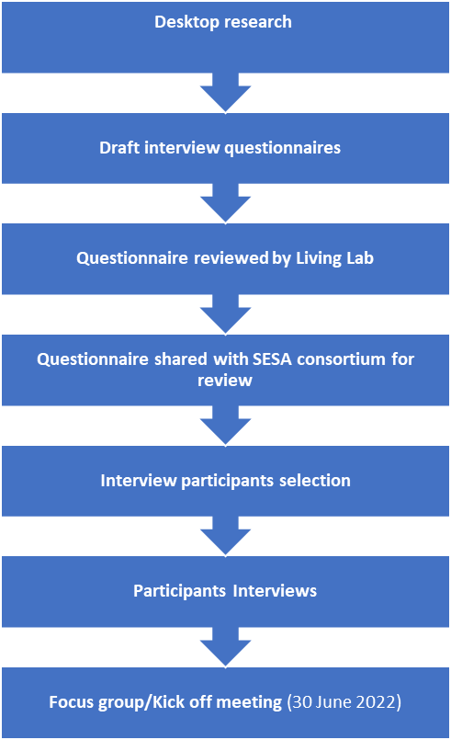

2.1. Desktop research
The capacity and skill needs assessment on energy use in the Living Lab sites began by undertaking extensive desktop research on each country and, where possible, the local site areas in the countries. The desktop research included reviewing peer-reviewed journal articles and grey literature. Grey literature included sources such as government and documentation developed through other work packages under the SESA project (for example, the Implementation plans developed for the Living Lab sites under the SESA project’s Work Package 4). While desktop research was underway, virtual engagements were held with the five Living Labs in Ghana, Kenya, Malawi, Morocco and South Africa as there was limited online information.

2.2. Engagements with Living Labs
The engagements with the five Living Labs in Ghana, Kenya, Malawi, Morocco and South Africa were arranged to 1) enhance the limited desktop findings, 2) advise the type of questions that might need to be included in the interview questionnaires, 3) identify which stakeholders should be contacted for interviews/questionnaires, and 4) identify some possible recommendations on how to reach these stakeholders. Findings from this engagement were added to the desktop findings where possible. They formed the basis for the initial version of the capacity and skill needs assessments and the Capacity Building Plan. The findings from the desktop research and Living Lab engagements require confirmation during the interviews as very little information was available during the desktop review process and Living Labs had limited information.

2.3. Semi-structured interviews and questionnaires
Following the desktop research and the engagements with the Living Lab teams in Ghana, Kenya, Malawi, Morocco and South Africa, the capacity and skill needs assessments and the Capacity Building Plan were enhanced by interviews with selected stakeholders.
Targeted sampling was used to select the interview participants for the semi-structured interviews in the five countries' Living Lab sites. Interview participants in each country were selected with support from the Living Lab site partners. More specifically, each of the Living Labs provided the key government departments, organisations and/or project implementation site beneficiaries (e.g., institution heads) that form a vital part of the Living Labs' implementation process.
The interviews were guided by a set of questionnaires developed for each participant. In addition, each interview participant was required to complete a SESA project consent form, in line with the ethical strategy. The questionnaires used to guide the interviews aimed to enhance the understanding of the present and future capacity in terms of sustainable energy solutions more generally, as well as the capacity levels in terms of the site-specific energy solutions being implemented. Doing so helped determine the possible capacity gaps and the possible tools and training that can be developed through SESA to address those gaps.

2.4. Focus group/kick-off workshop
An interactive focus group discussion with relevant stakeholders from Ghana, Kenya, Malawi, Morocco and South Africa took place in the form of a virtual “kick-off workshop” on 30 June 2022 after the interviews were completed. During the kick-off workshop, the interview/questionnaire findings were unpacked and formed part of a broader visioning exercise.

2.5. Ethical considerations
At the start of each interview as well as the focus group discussion (which was undertaken in English), all participants were sent a participation consent form which provided them with a brief overview of the study, the measures taken to secure ethical compliance prior to collecting data and alerted them to their rights as research participants. This included their right not to participate or not to answer; their ability to withdraw from the interview or study at any point; confidentiality of the information shared during the interview and focus group discussions, and lastly; the anonymity of their identities. Participants either signed the consent form or gave verbal consent to the form during the engagements. In addition to taking detailed notes, if permission was granted by the participants, the interviews and focus group discussion was recorded using a laptop, allowing for more substantive engagement and record of the findings.

2.6. Limitations
In terms of smart energy solutions in the Living Lab countries, there is limited information – especially peer-reviewed information – available from which to extract relevant information. Furthermore, it is essential to highlight that at this stage, all five Living Labs’ smart energy technology solutions still need to be implemented and finalised. As a result, the exact capacity, skills and needs required are not fully known yet.

3. Capacity and skill needs assessments
This chapter details the capacity and skill needs assessment findings for Kenya, Malawi, Ghana, South Africa and Morocco, respectively, in terms of sustainable energy development. The capacity and skill needs assessments for each country in this chapter detail the following: an overview of the country's context and background; SESA’s Living Lab project sites in the country; the country's energy governance structure; the various policies, plans and strategies that are relevant to the country’s energy landscape; the present capacity of local innovators and authorities on sustainable energy development; the future capacity (desired state) based on the Living Lab’s city vision for the sustainable energy use; the gaps between present capacity and future desired skills identified; and the relevant tools and training to fill the gaps.

3.1. Kenya

3.1.1. Country context and background
Kenya is a country located in the east of Africa, bordered by Somalia (to the east), Ethiopia (to the north), Uganda (to the west) and Tanzania (to the south), with its south-eastern border on the Indian Ocean. It covers an area of about 569,000 square kilometres, most of which (80 percent) is considered either arid or semi-arid.
One of Kenya’s greatest natural resources, Lake Victoria, is the largest freshwater lake in Africa and a key source of livelihood for the rural and urban communities adjacent to it. The lake is an important source of revenue for the country as a huge proportion of fish distributed in Kenya are sourced from the lake, and several irrigation schemes depend on it. The agricultural and fishing sectors dominate as key income drivers. In addition, there are many micro and small businesses, mostly consisting of market trade, small retail products, artisanal services, small-scale construction and transport, as well as some larger wholesale outlets.
As a developing country, Kenya is still characterised by high levels of poverty and unemployment, a lack of clean drinking water, and low access to electricity. However, as espoused in the 2018 Kenya National Electrification Strategy (KNES), the country wants to achieve universal electricity access by 2028 through main grid densification, intensification and expansion, and off-grid solutions. The strategy has a strong off-grid component and expects to provide approximately two million new connections by 2022. Already by 2018, 6.9 million people had been connected to the grid.
In addition to confronting energy access issues and in support of the Paris Agreement, Kenya has announced its commitment to achieving a 30 percent reduction in its national greenhouse gas (GHG) emissions by 2030, relative to the business as usual (BAU) scenario of 143 MtCO2e. Kenya’s Nationally Determined Contribution (NDC) has identified six main sectors responsible for the country’s GHG emissions, where mitigation efforts are focused: energy (electricity generation); transportation; agriculture; land use, land-use change and forestry (LULUCF); industrial processes and waste. However, this does not necessarily translate into a 30 percent emission reduction target for each of the six mitigation sectors, as each sector has widely differentiated mitigation potential and costs. Most of Kenya's GHG emissions result from agriculture LULUCF sectors, most likely due to the high reliance on wood fuel by a large majority of the population. With Kenya’s Vision 2030, every effort should be made to explore renewable resources to increase energy security for the country.
In terms of solar energy, Kenya receives daily solar insolation of 4-6 kWh/m², of which only a small portion (1 percent of the country’s energy mix) has been tapped (EPRA, 2022). Various mini-grids, embedded generation plants and utility-scale plants have been implemented across Kenya. Biogas in Kenya is extensively produced with over 8,000 biogas plants utilising various raw materials, such as agricultural wastes, slaughterhouse waste and municipal wastes. However, there is currently no consolidated data on biogas production, making it a challenge to determine the country’s overall capacity (ERPA, 2022).

3.1.2. Actions planned for Living Labs in Kenya
Through SESA, the main objective is to develop a modular demonstration project to provide sustainable energy access solutions that are relevant for validation and replication in both urbanised and rural contexts in Africa, creating opportunities to generate sustainable off-grid electricity with sector linkages such as cooking, lighting, fishing, water pumping, mobility and combining energy solutions with local InfoSpots to enable access to information on energy and digital skills. More specifically, in Kenya, the intention is to increase sustainable energy access through Solar Photovoltaic (PV) Hubs and the development of productive user cases to strengthen the Lake Victoria economy and livelihoods in Western Kenya. Demonstration implementation activities will be carried out at two project sites, Kisegi in Homa Bay County and Katito in Kisumu County.
The figures below (Figures 1 and 2) illustrate the layout and orientation of the solar panels at the two sites in Kenya:
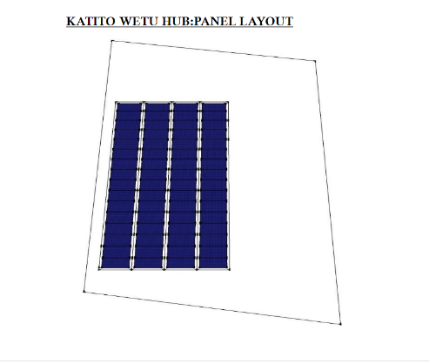
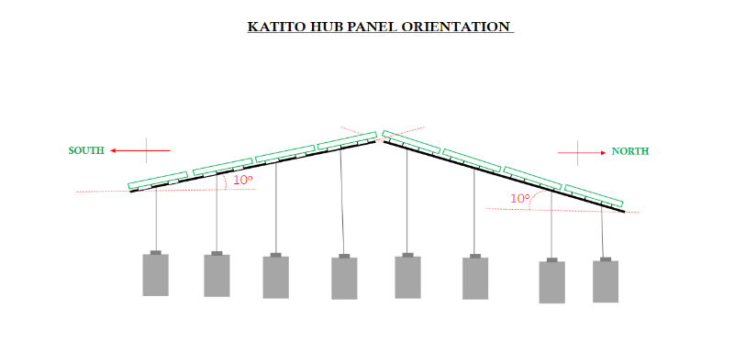
Figure 1: Katito solar panel layout and orientation
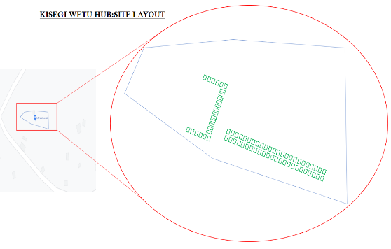
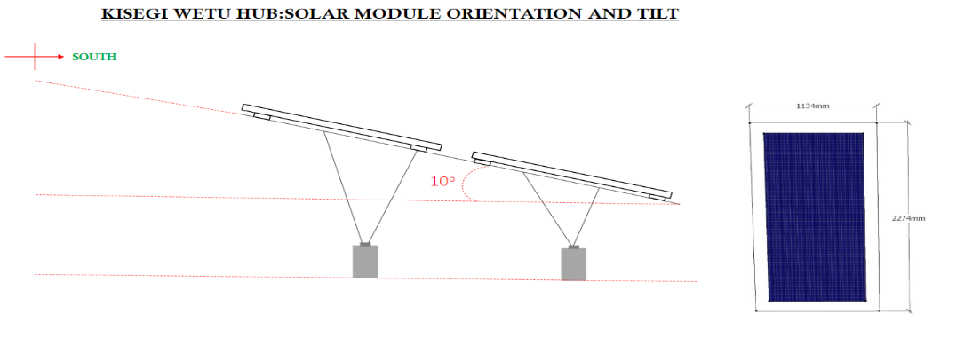
Figure 2: Kisegi solar panel layout and orientation
The key participants involved in the Living Lab in both Katito (Kisumu) and Kisegi (Homa Bay) are outlined in more detail in Table 1 below.

Table 1: Key Living Lab participants in Kenya and their role
Participant | Role and information about the participant
WE!Hub Victoria Limited (WeTu) | (Local demonstrator): “WeTu” – Swahili for “ours” – is powered by the social enterprise WeHub! Victoria Ltd. and is fully owned by Siemens Stiftung. WeTu works on innovative solutions for supplying energy and drinking water in communities surrounding Lake Victoria in Kenya. In addition, the company is deploying the first-ever electric vehicles specifically developed for rural Africa. When combined with social and ecological business models, these solutions are improving living conditions in the region, creating jobs, and establishing new economic opportunities.
Blekinge Institute of Technology (BTH) | (Research partner – provided technical support): BTH is a public, state-funded Swedish institute of technology in Blekinge located in Karlskrona, Sweden.
Basic Internet Foundation (BIF) | (Technology provider – internet information spots): aims at providing "free access to basic information on the Internet for everyone in the world".
United Nations Human Settlement Programme (UN-Habitat) and United Nations Environment Programme (UNEP) | (Project partner – capacity building and policy support): UN-Habitat, under the United Nations, promotes transformative change in cities and human settlements. UNEP is responsible for coordinating responses to environmental issues within the United Nations.
Local innovators | Local innovators will be engaged to develop components of the innovations such as the electric two wheelers and second life appliances of lithium battery cells.

3.1.3. Present and future capacity on sustainable energy development
Understanding the present capacity of local innovators and authorities on sustainable energy development and solutions is essential to map out the capacity and skills that might be needed to reach the desired state in terms of sustainable energy development. This section unpacks the national energy governance structures and policies put in place as well as the local policies both in terms of present capacity and future capacity (desired state) for sustainable energy development in the sites selected in Kenya.

3.1.3.1. Political and legal capacity
Kenya’s national energy governance and policy landscape form a vital component of the political and legal capacity for sustainable energy development at the county level. As a result, the national energy landscape will be outlined before discussing the present political and legal capacity for sustainable energy development in both Kisumu County and Homa Bay County.
There are a number of key public and private sector players who form a vital part of the energy landscape in Kenya. These are detailed below:

Ministry of Energy (MoE)
- The MoE is mandated to develop and implement policies that create an enabling environment for the efficient operation and growth of Kenya’s energy sector. The Ministry sets strategic directions to facilitate the growth of the sector while providing a long-term vision for all sector players (MoE, 2021).
- The core functions of the MoE (derived from the President’s Executive Order No.1 of 2018 (Revised June 2018)) are as follows:
  - National Energy Policy Development and Management
  - Thermal Power Development
  - Rural Electrification Programme
  - Energy Regulation, Security and Conservation
  - Hydropower Development
  - Geothermal Exploration and Development
  - Promotion of Renewable Energy (MoE, 2021)
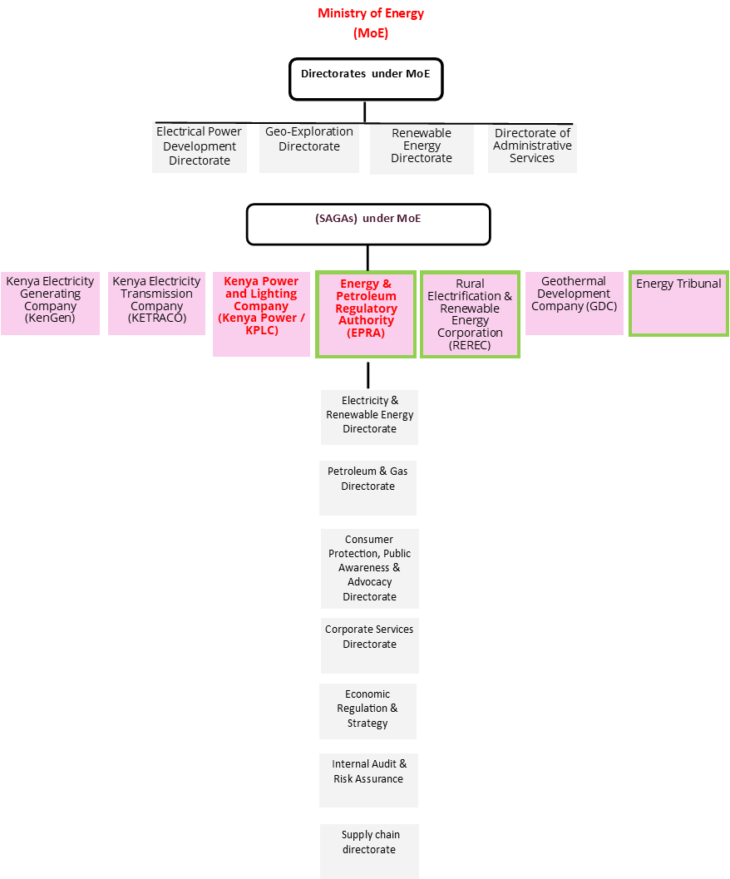
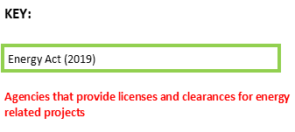
Figure 3: Directorates under the MoE and the Semi-Autonomous Government Agencies (SAGAs) under the MoE
- The SAGAs under the MoE (also illustrated in Figure 1) are as follows:
  - KenGen is the leading electricity power-generating company in Kenya, producing about 60 percent of electricity consumed in the country. The company utilises various sources of energy to generate electricity including hydro, geothermal, thermal and wind. It is owned 70 percent by the Government and 30 percent by public shareholders.
  - Kenya Electricity Transmission Company (KETRACO): The company is 100 percent Government owned. It is responsible for planning, designing, constructing, operating and maintaining a high voltage electricity grid.
  - Kenya Power and Lighting Company (Kenya Power/KPLC): Kenya Power is a state corporation. It is responsible for electricity transmission, distribution and retail sales. It manages energy purchase agreements with KenGen and the Independent Power Producers (IPPs) for onward transmission and distribution.
  - Energy and Petroleum Regulatory Authority (EPRA): EPRA is an independent statutory body with a regulatory mandate in the operations of the entire energy and petroleum sectors. EPRA exists to protect the interests of the consumer, investor and other stakeholders. It has the power to formulate and enforce secondary legislation. EPRA was established as the successor to the Energy Regulatory Commission (ERC) under the Energy Act, 2019 with an expanded mandate of inter alia regulation of upstream petroleum and coal (EPRA, 2021). The functions of the Authority are provided in Section 10 of the Energy Act 2019.
EPRA is responsible for leading the planning, development, implementation, promotion and execution of structures for the development and regulation of renewable energy and energy efficiency through research and planning, development of standards and regulations, compliance and enforcement. Other responsibilities include:
    - collecting and maintaining energy-related data;
    - preparing energy national plans;
    - initiating the development of standards and codes of practice for renewable energy and energy efficiency;
    - developing requisite regulations for recommending to the Minister for Energy;
    - providing information and statistics to the Minister for Energy as he may require from time to time;
    - designating energy consumers and maintaining a list of accredited energy auditors;
    - Licensing, monitoring and enforcement of renewable energy and energy efficiency regulations; and
    - advising the Commission, internal parties as well as external stakeholders on technical and regulatory matters relating to renewable energy and energy efficiency (EPRA, 2021).
  - Rural Electrification and Renewable Energy Corporation (REREC): The Rural Electrification Authority is charged with the mandate of implementing the Rural Electrification Programme. It is 100 percent Government owned. The Authority is expected to increase the speed of implementation of several projects that are lined up for implementation throughout the country (REREC, 2022).
  - Geothermal Development Company (GDC): This is a state-owned company responsible for geothermal resource assessments, including exploration, appraisal and steam production. It explores and develops steam fields and sells geothermal steam to KenGen and IPPs for electricity generation. (GDC, 2022)
  - Energy and Petroleum Tribunal (EPT)/Energy Tribunal: The Tribunal arbitrates disputes between the Energy and Petroleum Regulatory Authority and other aggrieved stakeholders in the energy sector.

Ministry of Environment and Forestry (MoEF), 2021)
- Departments under the MoEF:
  - Administration, Finance, Accounts, Human Resources Management, Human Resources Development, Public Communications, Planning, Information Communications Technology, Supplies Chain Management, Internal Audit and Legal
  - Directorate of Environment – Policy Formulation and Implementation (PF&I), Multilateral Environmental Agreements (MEAs), Programmes, Projects & Strategic Initiatives (PP&SI), Urban Rivers Programme (URP) and Climate Change (CC)
  - Directorate of Natural Resources – Forest Conservation (FC), Wildlife Conservation (WC)
  - Kenya Meteorological Department
- Semi-autonomous government agencies under the MoEF:
  - National Environment Management Authority (NEMA): The National Environment Management Authority (NEMA), is established under the Environmental Management and Co-ordination Act No. 8 of 1999 (EMCA) as the principal instrument of Government for the implementation of all policies relating to the environment (NEMA, 2022)
  - Kenya Water Towers Agency (KWTA)
  - Kenya Forest Service (KFS)
  - Kenya Forestry Research Institute (KEFRI)
  - National Environment Trust Fund (NETFUND)
- Environmental Management and Coordination Act (EMCA) Institutions
  - National Environment Council (NEC)
  - National Environment Trust Fund (NETFUND)
  - National Environment Tribunal (NET)
  - Public Complaints Committee (PCC)

Ministry of Devolution
- The State Department for Devolution (SDD) draws its mandate from Articles 6, 10 and Chapter 11 of the Constitution of Kenya; Executive Order No. 1 of June 2018 (Revised) and the various Acts under which devolution is implemented including; the Intergovernmental Relations Act, 2012; County Governments Act, 2012; Urban Areas and Cities Act 2011 and; Public Finance Management Act 2012 (Ministry of Devolutions, 2022). The Executive Order 1 of June 2018 (Revised) assigned the State Department the following functions:
  - Devolution Policy;
  - Intergovernmental Relations;
  - Capacity Building and Technical Assistance to County Governments;
  - Management, Monitoring and Evaluation for Devolution Affairs;
  - Special Programmes; and
  - Food Relief Management and Humanitarian Emergency Response.
- The National Government established a Ministry responsible for Devolution matters in order to manage the process of implementation of the devolved system of government. The National Government thereafter provided administrative support through the secondment of critical staff to assist in setting up county structures before Counties acquired the capacities to do so (Ministry of Devolutions, 2022).

National Treasury
- The State Department for Planning within Treasury is divided into seven Directorates:
  - Macroeconomic Planning and International Economic Partnerships
  - Social and Governance
  - Sustainable Development Goals (SDGs) projects and programmes coordination
  - Economic Development Coordination
  - Monitoring and Evaluation
  - Infrastructure, Science, Technology and Innovation
  - Public Investments Management (PIM)
- Public Private Partnership Unit (PPPU)

Ministry of Lands and Physical Planning
- The Ministry of Lands and Physical Planning is a central player in Kenya’s socio-economic development plan. Land is one of the key enablers of the "Big 4 Agenda" and the Kenya Vision 2030. Land is acknowledged as a key determinant of social, economic and political transformation (Ministry of Lands and Physical Planning, 2022).

Nuclear Power and Energy Agency (NuPEA)
- NuPEA is a State Corporation established under the Energy Act 2019. It is charged with the responsibility of promoting and implementing Kenya’s Nuclear Power Programme and carrying out research and development for the energy sector (NuPEA, 2022).
Kenya has several national policies, plans and strategies in place that promote sustainable energy development and solutions. Some of these are listed below.
- Vision 2030
- Green Economy Strategy and Implementation Plan (GESIP) (2016-2030)
- President Kenyatta’s Big Four Agenda (2018)
- Kenya’s Nationally Determined Contribution (NDC) (2017)
- Kenya’s Climate Change Act (2016)
- National Climate Change Action Plan (NCCAP) (2018-2022): This plan aims to strengthen the country's path towards sustainable, climate-resilient development while achieving low carbon climate resilient development.
- National Climate Change Response Strategy (NCCRS) (2010)
- Kenya National Adaptation Plan (NAP) (2015-2030): This plan builds on the foundation laid by the NCCRS and the NCCAP. Additionally, the NAP is the basis for the adaptation component of Kenya’s INDC. The aim of the NAP is to consolidate the country’s vision of adaptation supported by macro-level adaptation actions that relate to the economic sectors and county-level vulnerabilities to enhance long-term resilience and adaptive capacity.
- Other:
  - East African Community’s Climate Change Master Plan
  - National Spatial Plan (2015-2045)
  - National Climate Change Framework Policy (2016)
  - National Climate Finance Policy (2016)
  - Climate Change Bill (2014)
  - National Waste Management Strategy, Waste Policy and Climate Change Action Plan (2018-2022)
- National Energy Act (2019): An Act of Parliament to consolidate the laws relating to energy, provide for National and County Government functions in relation to energy, provide for the establishment, powers and functions of the energy sector entities; promote renewable energy; exploration, recovery and commercial utilisation of geothermal energy; regulation of midstream and downstream petroleum and coal.
- National Energy Policy (2018): the overall objective is to ensure an affordable, competitive, sustainable and reliable supply of energy at the least cost in order to achieve the national and county development needs while protecting and conserving the environment for intergenerational benefits.
- Devolution Policy
- Least Cost Power Development Plan (LCPDP) (2017-2037)
- Kenya National Electrification Strategy (KNES)
- Public Private Partnerships (PPP) Act (2013) – amended 2017
- Feed-in Tariff (FiT) Policy (2008) – amended 2010, 2012
- Kenya Off-Grid Solar Access Project (KOSAP)
- Bioenergy Strategy (2020)
- Kenya National Energy Efficiency and Conservation Strategy (2020)
- Scaling-Up Renewable Energy Plan (SREP)
- Kenya Electricity Modernization Project (KEMP)
- County energy plans
- Other:
  - Rural Electrification and Renewable Energy Corporation (REREC) Strategic Plan (2018-2023)
  - Sustainable Energy for All (SE4All) Action Agenda
  - Kenya Distribution Master Plan (2013)
  - Kenya Electricity Sector Investment Prospectus (2018-2022)
Many of Kenya’s national laws and regulations cascaded down to the county level, which include Kisumu County and Homa Bay County.

Kisumu County’s political and legal capacity
Kisumu County currently has a climate change act (Kisumu County Climate Change Act (2020), an environmental policy (Kisumu County Environment Policy (2019) as well as an integrated development plan (Kisumu County Integrated Development Plan II (2018-2022). While further information on the present capacity will be obtained from the interviews and kick-off workshop, some initial information from these documents can begin to paint a picture of the sustainable energy development capacity in the county.
The Kisumu County Climate Change Act (2020) was established for Kisumu to provide a regulatory framework for enhanced response to climate change, mechanisms and measures to achieve low carbon climate development, and financial mechanisms for implementation of climate change adaptation activities and connected purposes. Energy is one of the focal aspects of this policy.
Within the Kisumu County Environment Policy (2019) there are a number of statements, some of which are important to bear in mind in relation to the present capacity on sustainable energy development.
For instance, under section 5.9 Energy Use, Efficiency and Conservation the policy statement is as follows:
The County Government will:
a) Develop and promote an integrated county strategy for the generation and sustainable utilization of renewable energy.
b) Promote adaptation of the cleaner production concept in all energy production and consumption activities.
c) Promote investments in clean energy
d) Develop a system for energy management graduation for domestic, low and high industry consumers
e) Create public awareness with respect to clean energy and energy-efficient technologies
f) Facilitate public access to clean and affordable energy
Furthermore, under section 5.10 Climate Change the policy statement is as follows:
The County Government will:
a) Develop and implement a comprehensive County Climate Change Policy.
b) Strengthen the capacity for county-level institutions to support national climate resilience, and low carbon development through integrating climate change into implementation strategies.
c) Develop and implement awareness-raising strategies and capacity development on the opportunities for adaptation and mitigation measures as per the national climate change action plan and response strategy.
d) Strengthen and enhance early warning and response systems for climate and disaster risk reduction.
e) Enhance the adaptive capacities of marginalised groups
f) Build and strengthen research capacity on climate change and related environmental issues. g) Put in place a climate financing mechanism that will help the county take advantage of new and emerging climate change funds and also include innovative ways to fund climate change actions domestically by committing a percentage of the annual county development budget to climate-related interventions.
h) Upscale the role of the private sector in combating climate change
i) Involve and empower communities in mitigating and adapting to climate change.
The Kisumu County Integrated Development Plan II (2018-2022) is a five-year framework which guides the county’s development activities and is a requirement for receiving funds according to the Public Finance Management Act. There are several key takeaways from this plan. Firstly, the “promotion of sustainable energy sources in industrialization and service sector development” and the “promotion of sustainable energy sources in industrialization and service sector development”, amongst others are noted as key priorities in the Kisumu County Integrated Development Plan II; secondly, according to this development plan, Kisumu County has “ not fully tapped into the potential of solar power and renewable energy”; and lastly, this plan is dated to inform the years 2018 to 2022, which means it will not be in effect as of next year. This last point will come into discussion at a later stage.

Homa Bay County’s political and legal capacity
Homa Bay County, similarly to Kisumu County, has a few policies and plans in place to support sustainable energy development in the county.
Homa Bay County’s Climate Change Policy (2021) aims to effectively address all climate change-related communal issues while promoting socio-economic activities to support a stable and thriving County. Under this policy, it is stated that the County government will, amongst others, “promote adoption of renewable, sustainable and efficient energy technologies for domestic and industrial use”.
In addition, there is also the Homa Bay County Integrated Development Plan II (2018-2022). The County Integrated Development plan outlines Energy, Infrastructure and ICT Development Priorities and Strategies for Homa Bay. According to this development plan, the majority of Homa Bay county residents rely heavily on fuel wood and charcoal for cooking. This, together with the expected growth in electricity demands means the County Government plans to meet the deficit by facilitating investments in solar, geothermal and biomass power generation plants, which have significant power generation potential in the County. The integrated development plan also stipulates that Homa Bay County Government “intends to increase energy access to the remaining population by having them connected through maximisation of existing power systems network, extending system networks to underserved areas, installing more transformers in identified settlement sites or subsidising the cost of connection.” However, similar to Kisumu, it is worth noting that the duration of the integrated development plan is from 2018-2022, meaning it will not be in effect from next year (2023) onwards.

3.1.3.2. Economic and social capacity
As showcased in the section above, Kenya has several national government bodies that govern the energy sector, which includes renewable energy technologies, in the country. In addition, interview participants noted that all counties in Kenya have their own energy departments. The presence of these energy departments at the local level was noted to be a pivotal step in the management of energy resources at the county level.
In terms of local innovators, according to the implementation plan developed for the sites in Kenya under SESA’s work package 4, there are several companies marketing solar home systems, mainly for lighting, but also for phone charging and other small appliances such as TV, radio and torch. It is noted that some companies, such as Power Hive, are implementing solar mini-grids in some communities in the neighbouring county of Kisii and including electric motorbikes as part of their program. However, while the solar companies have reached rural communities, what they offer is fairly limited. As a result, there is a need to further develop the sector in order to enhance access to clean energy solutions throughout the region and among community residents.

3.1.4. Gaps between present capacity and future desired skills
In order to meet the future, desired capacity on sustainable energy development, and ensure the correct capacity gaps are filled through the SESA project deliverables moving forward, the various capacity gaps that have been identified for Kenya (and particularly for Kisumu and Homa Bay) are outlined below.

3.1.4.1. Political and legal capacity gaps
Kenya has a number of national energy laws and regulations which incorporate aspects of renewable energy technologies. As previously mentioned, many of these laws and regulations cascaded down to the county level. However, capacity gaps in relation to the energy policy landscape are still present. For instance, there also appears to be a lack of adoption of adequate legal and policy frameworks by the county administration and respective county assemblies. This may in part be due to extenuating factors including challenges related to competing demands on resources and institutional capacity constraints. This is exacerbated by the county assembly's lack of technical expertise and inefficiency in formulating adequate renewable energy legislation at the local level. Interviews with the national government confirmed this - where it was noted that many counties in Kenya are not ready with their energy regulations and policies. Many counties in Kenya are currently placing focus on non-energy-related aspects.
It is worth pointing out that both Homa Bay County and Kisumu Country’s Integrated Development Plans are almost at the end of their term. This means that there is a potential gap that will arise from 2023 onwards in terms of county-level development planning.

3.1.4.2. Economic and social capacity gaps
In terms of economic and social capacity gaps relating to sustainable energy technologies in Kenya, the findings suggest the presence of capacity gaps relating to knowledge and awareness; human resource capacity and skills, as well as access to finance.
Knowledge and awareness: A lack of sufficient knowledge on sustainable energy technologies is said to be a serious challenge in Kenya (Takase, 2021). According to interview participants, most people in Kenya do not know much about renewable energy technologies and their benefits. This lack of knowledge can likely result in poor usage and/or a lack of capacity to maintain the energy technology systems. For example, in the implementation plan developed by the Living Lab for Kenya under SESA’s work package 4, it is noted that there is still relatively low awareness of solar power being used for charging batteries for e-mobility or other electronics more than small lights. It will take time for communities to get used to electric vehicles and trust the technology.
According to the Living Labs (and the implementation plan), there is currently insufficient data on the energy resource use and base in and around the Lake Victoria basin region. In the region, the same is true for renewable energy sources and related technologies. There is no obvious distinction between on-demand and consumption in the data given. The Living Lab has noted this to be a problem that has to be addressed as soon as possible. The way information is communicated and presented is also critical.
Human capacity and skills: As previously noted, there is a lack of technical expertise and capacity in relation to energy regulation. This was echoed by research participants and was said to include limited capacity and skills in formulating adequate renewable energy legislation, financing, licensing and monitoring and evaluation processes related to renewable energy technologies.
Interview participants highlight that there is a lack of data showcasing the current energy supply and demand in Kenya. A lack of sufficient or accurate energy supply and demand data can make energy sector planning and decisions difficult to execute (International Energy Agency, 2022).
Access to finance: During interviews, financing was noted as a key component to Kenya's success of renewable energy technology initiatives. One interview participant noted the need for investor-friendly laws in Kenya to increase financiers to venture into renewable energy opportunities in Kenya.

3.1.5. Tools to fill capacity gaps
Through the SESA project, various tools can be undertaken to address the capacity gaps in Kenya relating to sustainable energy development outlined in the previous section. These tools include:
- A workshop with decision-makers on relevant renewable energy policy development showcasing approaches for effectively integrating relevant renewable energy technology components into county-level laws and regulations. This can also include revised development plans for target counties.
- A dialogue with decision-makers on the relevant renewable energy licensing to unpack and enhance licensing procedures and processes. It is important to note that interview participants suggested that invites for such workshops be sent through the Ministry of Energy and Councillor of Governors in Kenya. Taking such an approach means that not only will the national government be aware of the event and be more likely to buy into the event, but it also means that the likelihood of local governments responding to the event invite and attending the event may be higher as the national government supports the event.
- Development of communications materials to explain climate change and its impacts in the African context in an easy-to-understand and visual manner. Development of communications products showcasing the benefits of renewable energy technologies in urban Africa.
- Development of communications products showcasing the benefits of renewable energy technologies in urban Africa.
- Development of communications products briefly explaining the site-specific technologies (what they are, their benefits and how they work) in Kisumu and Homa Bay in a visual and easy-to-understand manner.
- Explaining the site-specific technologies maintenance aspects to a user through communications products or trained members of the community. If members of the community are a suitable option, a train-the-trainer approach will be needed to ensure the selected maintenance members are aware of all the relevant maintenance information.
- Energy monitoring and evaluation dialogue for relevant local authorities in Kenya.
- Small business development modules for the Living Lab and local innovators in Kenya.
These tools are presented in a consolidated table with all the countries in Chapter 4.

3.1.6. Summary of results
A summary of the results is provided in the Table below.

Table 2: Summary of results for Kenya
Thematic area | Present capacity of local innovators and authorities on Sustainable Energy Development | Future capacity (desired state) based on the city’s vision for the Sustainable Energy Use | Gaps between present capacity and future desired skills | Tools and training modules to fill these gaps
Political and legal | There are several national and local policies, strategies and plans that support sustainable energy development | Strengthened environment for developing, enhancing and implementing policies, strategies and plans relating to sustainable energy development | Lack/delay in formation or adoption of adequate legal and policy frameworks by county administration and assembly  Lack of policy formulation expertise and efficiency  Lack of expertise and efficiency around energy licensing  The Kisumu County Integrated Development Plan II (2018-2022) and the Homa Bay County Integrated Development Plan II (2018-2022) coming to an end. | Workshops with decision-makers on approaches for effective integration into revised development plans for target counties  Dialogue with decision-makers on the relevant renewable energy licensing to unpack and enhance procedures and processes  Dialogues and/or training sessions on monitoring and evaluating processes for renewable energy technology projects being implemented at the local level  Learning session(s) for Living Labs and/or local innovators unpacking the basics around small business development in relation to sustainable energy technologies
Knowledge and awareness | Limited knowledge on renewable energy, including solar PV technology | High level of awareness on renewable energy, including solar PV technology | Lack of sufficient knowledge on renewable energy technologies. This can likely result in reduced buy-in, poor usage and/or a lack of capacity to maintain the energy technology systems | Communications products and/or e-learning module to raise awareness and enhance understanding on the benefits and opportunities of the renewable energy technology  Communications products briefly explaining the site-specific solar PV technologies (what they are and the associated benefits) in Kisumu and Homa Bay in a visual and easy to understand manner  Explain the site-specific technologies (Solar PVs) to users through communications products or through trained members of the community
Human capacity and skills of community | Low level understanding and skill related to solar PV technology | Enhanced capacity and skills of local innovators in relation to Solar PV hubs operation and maintenance | A lack of understanding on Solar PVs and more specifically, the solar PV hubs functions | Communications products briefly explaining the site-specific solar PV technologies (what they are and the associated benefits) in Kisumu and Homa Bay in a visual and easy to understand manner  Training innovators on the operation and maintenance procedures required in relation to the Solar PV hubs  Communication products explaining climate change causes and impacts in Africa
Skills of local innovators | Some level of skill amongst new, small-scale solar PV companies, however the scope of the technology is limited | Sound understanding of Kenya’s energy policy landscape to upscale and replicate energy solution | Mapping of possible policy, strategy and/or plan entry points for replicating energy solution | Innovator training, workshops and videos on solar PV technology utilisation and associated benefits in a visual and easy to understand manner  Learning session(s) for Living Labs and/or local innovators unpacking the basics around small business development in relation to sustainable energy technologies
Access to finance | Little access to finance to fund solar PV investment | Improved conditions to access finance to fund solar PV investment | Develop financial instruments and technical assistance to improve fiscal access | Awareness-raising and technical assistance to financial institutions and individuals to increase access to finance to fund solar PV investment  Financial instruments developed for increased access to finance to fund solar PV investment

3.2. Malawi

3.2.1. Country context and background
Malawi is a landlocked country in southeast Africa. In 2017, approximately 10 percent of Malawi’s population had access to electricity and 87 percent of the population was still dependent on biomass for cooking using firewood. Firewood dependency and charcoal production for cooking continues to cause severe national deforestation, exacerbating the impact of flooding disasters in Malawi (Buckland et al., 2017).

3.2.2. Actions planned for Living Lab in Malawi
In Malawi, the traditional use of biomass in everyday household work is associated with significant negative environmental and health effects such as deforestation and indoor air pollution. Adopting clean and efficient cooking technologies requires attention on how to bring the stove adoption to scale. Adoption is affected by various factors that cut across the value chain. Therefore, the challenge is implementing stoves fired with sustainable biomass that render tangible health, environmental, and social benefits to the target populations. A circular energy solution for clean cooking, clean water and agriculture in rural areas of Malawi is the BioCooker, which will be produced at the demo site in Waliranji-Mchinji in Malawi.
The objective of the Malawi demonstration innovation is to:
- adapt and validate the BioCooker as a small-scale and commercial product in order to be easily implemented in the selected region;
- develop a local material supply chain by testing new biomass alternatives for the selected regions to reduce deforestation and pressure on forests; and
- enhance the recovery of nutrients by producing secondary bio-products, including soil improvers such as biochar, and develop new value chains and a circular business model for local entrepreneurs, supporting them in an acceleration process.
There is a need to shift from unsustainable biomass energy sources to sustainable and diversified renewable energy production; hence the BioCooker will play a great role as it converts biomass fuels to produce heat for cooking and biochar. The biochar is used as an affordable water purification system and enriching soil for agriculture. The BioCooker also has USB ports to provide electricity. The demo will provide a circular and sustainable business model with high replication potential, to be available to local entrepreneurs. The project partners include: The Research Institute of Sweden AB (RISE) (Research partner – support testing activities in the demonstration); Make it Green Solutions (SME) (responsible for providing test units of the BioCooker, blueprints for the local production, supervision and checks of the production, as well as organising the fuel chain); and Going Green (local partner). The key participants involved in the Living Lab in Malawi are outlined in more detail in Table 3 below.

Table 3: Key Living Lab participants in Malawi and their role
Participant | Role and information about the participant
Research Institute of Sweden AB (RISE) | (Research partner – support testing activities in the demonstration): RISE Research Institutes of Sweden is Sweden’s research institute and innovation partner. Through international collaboration with industry, academia and the public sector, RISE ensures business competitiveness and contributes to a sustainable society.
Make it Green Solutions | (A small-to-medium enterprise responsible for providing test units of the BioCooker, blueprints for the local production, supervision and checks of the production, as well as organising the fuel chain): Make It Green Solutions AB is a Swedish cleantech company. They undertake research and development of sustainable solutions for clean energy, water and agriculture. The results are an innovative range of products, services and consulting intended for a global market aimed at reducing the overall carbon footprint.
Going Green | The local partner who will manufacture the BioCooker locally according to blueprint work with the distribution, training and supervision on how to properly use the cookstove.

3.2.3. Present and future capacity on Sustainable Energy Development
This section unpacks the present and future (desired state) capacity on sustainable energy development in Waliranji-Mchinji, Malawi.

3.2.3.1. Political and legal capacity
There are several key public and private sector players who form a vital part of the energy landscape in Malawi. These are detailed below.

Ministry of Energy:
● Department of Energy Affairs (DoEA): Currently the DoEA is the only constituent department of the Ministry of Energy. The DoEA’s main functions include the formulation and coordination of energy policies, planning, information communication and technology; the provision of rural electrification services; the provision of alternative energy and energy conservation services as well as the coordination of research and development in the sector (MoE, 2022).
Minister of Natural Resources, Energy and Mining (MoNREM): acting through the Department of Energy Affairs (DoEA) and Malawi Energy Regulatory Authority (MERA) (MiNREM, 2022).
Electricity Supply Corporation of Malawi (ESCOM) Limited: responsible for the transmission and distribution of electricity in Malawi.
Malawi Energy Regulatory Authority (MERA): responsible for regulating the Petroleum Industry; the electricity industry; the renewable energy industry; ethanol, coal industry and all biofuels production and utilisation.
National Oil Company of Malawi (NOCMA): responsible for the management of the country’s strategic fuel reserve facilities, promoting competition in the oil and gas industry and promoting oil and gas exploration activities for stability and security of supply of liquid fuel and gas products.
Electricity Generation Company (Malawi) Limited (EGENCO): responsible for the generation of electricity in Malawi.
Power Market Limited (PML): responsible for single operating single buyer functions.
Ministry of Finance (MoF): The mandate is to formulate economic and fiscal policies that seek to manage government finances and provide strategic guidance on economic and development planning based on accurate and reliable statistics for the attainment of social-economic development. The Ministry headquarters provides leadership for the whole Ministry. The Ministry headquarters is headed by the Secretary to the Treasury (MoF, 2022).
The Malawi Renewable Energy Partnership Group (MREPG): was formed immediately after the publication of the Malawi Renewable Energy Strategy (2017) and was tasked with delivering the actions within the Malawi Renewable Energy Strategy (2017) as well as recommending new actions in future as the sector develops.
Community Energy Malawi (CEM): CEM provides services in Networking organisations and individuals with an interest in renewable energy; raising awareness of the potential of renewable energy; capacity building in renewable energy technologies; lobbying and advocacy on renewable energy, and; fundraising for and funding renewable energy technologies. CEM will endeavour to provide detailed and timely support on community energy projects. The organisation will also help bring together policymakers, energy suppliers, installers and users to find innovative ways to develop community energy. CEM has produced a toolkit on Renewable Energy Technologies (Community Energy Malawi, 2022).
Rural Electrification Fund (REF): Amongst other items, the REF funds the Malawi Rural Electrification Programme (MAREP).

Rural Electrification Management Committee
District Energy Officer: According to the Malawi Renewable Energy Strategy (2017) and Buckland et al., 2017, the Government of Malawi is expected to implement a District Energy Officer role to support energy sector decentralisation (expected in all 28 Malawi districts by 2022). These officers will perform a range of duties, from advising the public to informing local energy plans, all to meet the aims and objectives of the MRES. According to the Renewable Energy Strategy (2017), there is currently a pilot project ongoing to determine the exact role of the district energy officers.
Malawi also has several national policies, plans and strategies in place that promote sustainable energy development and solutions. Some of these are listed below.
- Malawi’s National Energy Policy (2018)
- Malawi National Renewable Energy Strategy (2017): The National Energy Policy (2018) and the Malawi Renewable Energy Strategy (2017) build on the targets laid out in the Sustainable Energy for All Action Agenda (2017) and provide high-level policy direction, complemented by detailed technical analysis made available in the most recent Integrated Resource Plan (2017).
The Government of Malawi's (GoM) Renewable Energy Strategy sets out detailed priorities and actions to achieve the following vision for renewable energy in Malawi: universal access to renewable electricity and a sustainable bioenergy sector.
- Malawi National Electrification Strategy & Action Plan (2019)
- Sustainable Energy for All Action Agenda (2017)
- Integrated Resource Plan (2017)
- Regulatory Frameworks for Mini-Grids (2019)
- Malawi Feed-in Tariff Policy (2012)
- Malawi Biomass Energy Strategy (2009)

3.2.3.2 Economic and social capacity
Like Kenya, the present and future economic and social capacity for Malawi will focus on the following sub-categories: knowledge and awareness; human capacity and skills; and access to finance to upscale sustainable energy development solutions.

3.2.4. Gaps between present capacity and future desired skills
To meet the future desired capacity for sustainable energy development and ensure the correct capacity gaps are filled through the SESA project deliverables moving forward, the various capacity gaps identified for Malawi (especially for Waliranji-Mchinji) are outlined below.

3.2.4.1. Political and legal capacity gaps
As noted in the previous section, Malawi has several policies, strategies and plans available at the national level. The question that needs to be explored is the political and legal capacity at the local levels in Malawi. There is currently insufficient information on the capacity gaps at the local level. Therefore, this aspect will need to be enhanced through other deliverables undertaken through SESA (such as deliverable 5.2. focusing on policy development, institutionalisation and integration in local and national plans).

3.2.4.2. Economic and social capacity gaps
In terms of economic and social capacity gaps relating to sustainable energy technologies in Malawi, the findings suggest the presence of capacity gaps relating to knowledge and awareness as well as human resource capacity and skills.
Knowledge and awareness: Study participants expressed a lack of education on renewable energy technologies (including BioCookers), climate change and deforestation at the community level in Waliranji-Mchinji. In addition, participants noted the need for community members to change their cooking approaches and behaviours. Importantly, findings suggest that English is not widely spoken or understood in Waliranji-Mchinji. It was noted that the most common languages spoken by residents in the area are Chichewa and Chitumbuka. In addition, many of the residents are illiterate, meaning they cannot read or write in these languages.
Human capacity and skills: Monitoring and evaluation were areas with significant capacity gaps in Malawi. Monitoring and evaluation relating to renewable energy technology processes contain a variety of aspects. However, the exact aspects that require attention were not specified. Furthermore, through interviews, it was highlighted that there is limited knowledge amongst local innovators and community members on diverse ways of making biomass briquettes for BioCookers.

3.2.5. Tools and trainings to fill capacity gaps
Below are various possible tools that could be implemented in Malawi to address some of the capacity gaps identified in relation to sustainable energy development.
- Development of communications materials to explain climate change and its impacts in the African context in an easy-to-understand and visual manner. Development of communications products showcasing the benefits of renewable energy technologies in urban Africa.
- Development of communications material to explain deforestation and its impacts on Malawi’s populations.
- Development of communications products showcasing the benefits of renewable energy technologies, especially the BioCooker, to Malawi authorities and communities in Waliranji-Mchinji.
- Development of communications products briefly explaining the site-specific BioCooker (what it is, its benefits, and how it works) in Waliranji-Mchinji in a visual and easy-to-understand manner in Chichewa and/or Chitumbuka.
- Explain the site-specific technologies maintenance aspects to a user through communications products or trained community members. If community members are a suitable option, a train-the-trainer approach will be needed to ensure the selected maintenance members are aware of all the relevant maintenance information.
- Energy monitoring and evaluation dialogue for relevant Living Lab members and local authorities.
- Small business development modules for the Living Lab and local innovators in Malawi.
- Briquette-making session showcasing new ways of making suitable briquettes for the BioCooker.
An important finding is that most community members in Waliranji-Mchinji cannot understand, speak or read English. Chichewa and Chitumbuka are the most common and thus preferred languages to communicate in. Furthermore, many of these community members are not fully literate, meaning audio and visual communications materials are most suitable. This is an essential component to bear in mind when developing capacity-building tools for Malawi.

3.2.6. Summary of results
A summary of the findings for Malawi is provided in Table 4 below.
Table 4: Summary of results for Malawi
Thematic area | Present capacity of local stakeholders on Sustainable Energy Development | Future capacity (desired state) based on the city’s vision for the Sustainable Energy Use | Gaps between present capacity and future desired skills | Tools and training modules to fill these gaps
Policy and planning | Several policies and strategies are in existence relating to energy and Malawi’s vision for resilience | Strengthened environment for enhancing policies and strategies relating to energy and Malawi’s vision for resilience | Development of enabling environment | Institutional training and awareness-raising for supporting energy resilience at different scales
Knowledge and awareness | Limited knowledge on climate change, deforestation and renewable energy technologies | High level of awareness on climate change, deforestation and renewable energy technologies, including BioCooker technology | Lack of sufficient knowledge on renewable energy technologies (including BioCookers), climate change and deforestation | Communications products and/or e-learning modules to raise awareness and enhance understanding of the benefits and opportunities of the renewable energy technology  Communication products explaining climate change and deforestation causes and impacts in Malawi
Human capacity and skills of community | Low level of community understanding and skill related to BioCooker technology | High level of community skills on BioCooker technology, benefits and utilisation | Development of BioCooker technology understanding and utilisation | Training on new/innovative ways to make biomass briquettes for BioCookers in Waliranji-Mchinji  Explain the site-specific technology’s (BioCooker) maintenance aspects to a user through communications products or through trained members of the community
Skills of local innovators | Some level of skill, especially amongst innovators in the Cooking Stoves Association of Malawi – the body that governs anything to do with cookstoves in the country in collaboration with GIZ (The Deutsche Gesellschaft für Internationale Zusammenarbeit) | High level of innovator skills on BioCooker technology production, utilisation and marketing | Development of training for BioCooker production | Explain the site-specific technology’s (BioCooker) maintenance aspects to a user through communications products or through trained members of the community

3.3. Ghana

3.3.1. Country context and background
Ghana spans the Gulf of Guinea and the Atlantic Ocean to the south, sharing borders with the Ivory Coast in the west, Burkina Faso in the north, and Togo in the east. Ghana’s National electricity coverage has expanded over the years, but there is still an over-reliance on hydropower and fossil-fuel (thermal) energy sources. In Ghana, though electricity remains the main source of power for lighting for 88.6 percent of urban households, electricity use for lighting in rural households is less than 50 percent. Nationally, energy for cooking is largely dependent on the use of wood (41.3 percent), charcoal (31.5 percent) and gas (22.3 percent). In urban areas, 43.6 percent of households use charcoal for cooking (Energy Commission, 2021).

3.3.2 Actions planned for Living Lab
The demonstration project in Ghana explores clean cooking through waste-to-biogas solutions for cooking and solar solutions for lighting and internet access. The demonstrations will reduce sanitation problems and provide clean energy to the community. The demonstration will encompass business models, capacity building on construction and maintenance of the plants, and other activities to deliver a complete value chain in Ga North Municipal District and/or Atwima Nwabiagya Municipal District. The key participants involved in the Living Lab in both sites in Ghana are outlined in the table below.
Table 5: Key participants in Ghana and their role
Participant | Role and information about the participant
Akenten Appiah-Menka University of Skills Training and Entrepreneurial Development (AAMUSTED, Kumasi) | Local Demonstrator
Leitat Technological Center, Spain | (Technology provider – bioelectrochemical system)
Technalia, Spain | Technology provider – solar PV – micro smart grids
Local small-to-medium enterprises | Support in local implementation of demonstration activities

3.3.3. Present and future capacity on Sustainable Energy Development

3.3.3.1. Political and legal capacity
There are several key public and private sector players who form a vital part of the energy landscape in Ghana. These are detailed below.
- Ministry of Energy
- Commission and the Integrated Resource
- Resilience Planning (IRRP) team
- Volta River Authority (VRA)
- Bui Power Authority (BPA)
- Ghana Grid Company Limited (GRIDCo)
- Electricity Company of Ghana (ECG)
- Northern Electricity Distribution Company (NEDCo)
- Enclave Power Company (EPC)
- Public Utilities Regulatory Commission (PURC)
- Energy Commission of Ghana (EC)
- Ghana National Petroleum Corporation (GNPC)
- Ghana National Gas Company Ltd. (GNGC)
- Local District Medium Term Development Plans (DMTDPs) of the municipality
Despite significant efforts to mainstream sustainable energies into Ghana’s national policies, the extent to which such energies are integrated into local government plans in Ghana is limited – partly due to extenuating institutional, social and economic factors (Akrofi and Akanbang, 2021).
Ghana has several national policies, plans and strategies that promote sustainable energy development and solutions. Some of these are outlined below.
The Ghana Renewable Energy Master Plan (REMP) (2019), which has set a goal of 10 percent renewable energy in Ghana's electricity mix by 2030 and renewable energy in 1,000 off-grid villages by 2030, is a recent government policy initiative that attempts to explore Ghana's renewable energy potential. REMP also promotes local content and participation in the renewable energy sector (Ministry of Energy, 2019).
However, as noted in the draft SESA demo implementation plan, there is little effort taken on the ground to meet these new renewable energy targets. Both governmental and non-state enterprises are working on solar energy projects in Ghana. On the other hand, Ghana has not been able to progress from demonstration projects to large-scale adoption of solar and other new renewable energy. New renewable energy currently makes up less than 1 percent of the grid's energy mix.

The broad strategies proposed for the successful implementation of the REMP are as follows:
- Boost and sustain local assembly and manufacture of renewable energy technologies (RETs) through a systematic phasing out of import duty exemptions on RETs where the country has a competitive advantage.
- Strategically recommend consideration for tax exemptions on components and materials for assembly and manufacture to make RETs competitive in the local and sub-regional markets.
- Provide support to existing RET assembling and manufacturing companies, including preferential procurements under public financed projects.
- Guarantee local market through local content and local participation actions.
- Support the private sector through concessional financing and government on-lending facilities for renewable energy investments.
- Institutionalise competitive procurement to achieve cost reduction in tariffs for utility-scale renewable energy projects.
- Continuously provide investment support for the upgrading of the National Interconnected Transmission System to accommodate the planned renewable energy power targets.
- Incorporate land requirements for renewable energy projects in the national spatial planning framework.
- Develop legislation to ensure that increased development of renewable energy projects does not become detrimental to the environment.
- Intensify awareness creation.
- Build capacity in various aspects of renewable energy development.
- Support research and development.
- Explore opportunities to develop a market and production hub for electric vehicles in Ghana.
In line with the Renewable Energy Act, 2011 (Act 832) – which provides legislation for the development, management, use, sustainability, and adequate supply of renewable energy for generating heat and power – the Ministry of Energy will implement the plan through the REMP Coordinating Unit (REMP-CU).
The Ghana Energy Commission is the governmental agency responsible for national policies on renewable energy and energy efficiency, including regulatory checks. The municipal assemblies responsible for developing and enforcing planning and environmental policies lie within their respective communities.

Ga North policy and legal capacity
Ga North Municipal Assembly has an Annual Action Plan (Ga North Municipal Assembly (GNMA) Annual Action Plan (2022)). However, the policy landscape at the local level is currently not readily available to the public. Therefore, additional information on the current capacity in Ga North will need to be obtained through interviews and the kick-off workshop with selected participants in Ghana.

Atwima Nwabiagya policy and legal capacity
Similarly, the policy landscape for Atwima Nwabiagya is currently not readily available to the public. As a result, additional information on the current capacity in Atwima Nwabiagya will also need to be obtained through interviews and the kick-off workshop with selected participants in Ghana.

3.3.3.2. Economic and social capacity
Ghana's present and future economic and social capacity focuses on the following sub-categories: knowledge and awareness, human capacity and skills, and access to finance to upscale sustainable energy development solutions.
Education and awareness: Study findings suggest that the current level of education and awareness around Solar PVs and biogas technologies is still relatively low. Public misunderstanding about such technologies results in a slow uptake or transition to these sustainable energy solutions.
Human capacity and skills: The current human resources and technical skills to operate and maintain the renewable energy technologies implemented through SESA are relatively low. However, other institutions have done similar work, including the construction of utility-scale waste-to-electricity plants in one of the original municipalities selected for the demonstration. In addition, willingness to service and maintain the technology is present among the community users.
Access to finance: The present and future capacity for financing sustainable energy development in Ghana is unclear. There are no ready funding opportunities for supporting upscaling. Proper awareness of the economic viability of these technologies may encourage local financial institutions to create special micro and medium-scale financing schemes as there may be private funds to support the up-scaling of renewable energy solutions.

3.3.4. Gaps between present capacity and future desired skills

3.3.4.1. Political and legal capacity gaps
As noted, despite significant efforts to mainstream sustainable energies into national policies, the extent to which such energies are integrated into local government plans in Ghana remains unclear. Akrofi & Akanbang’s (2021) study explored the status and factors affecting the integration of sustainable energies in local level planning using the Wa Municipality in the Upper West Region as a case study. “Access to sustainable energy, especially in rural areas, can be greatly enhanced if national policies promote decentralised development planning and service delivery, especially when local governments are given the mandate and capacity to address community energy needs. Havet et al. stress that the involvement of local people and institutions in the planning and implementing of sustainable energy projects can enhance government accountability in delivering modern energy services” (Akrofi and Akanbang, 2021).

3.3.4.2. Economic and social capacity gaps
Knowledge and awareness: As mentioned, findings showcase limited public awareness and a lack of information about the cost and benefits of renewable energy technologies, which affects public acceptance of renewable energy technologies. Misinformation on technologies that utilise, for example, waste-to-biogas can be easily misconstrued and therefore perceived with hesitation and/or suspicion. Face-to-face education, online training schemes, and information videos are useful to spread awareness of renewable technologies.
Human capacity and skills: Despite similar projects being implemented in Ghana, the level of skill to use, implement and maintain renewable energy technologies is low amongst potential innovators and users. Findings suggest that there is a lack of technical skills to operate and maintain renewable energy technologies, project development skills as well as a lack of adequate training centres in the local site areas. A further focus area is the lack of maintenance knowledge, culture, and service providers. In-person training and workshops with practical demonstrations for users are crucial to overcoming these gaps. In addition, short and easily understandable online e-learning modules, such as MOODLE, were recommended to allow flexibility in learning as participants may be encouraged to learn at their own pace. It also allows for wide coverage with less funding. Furthermore, information outputs such as videos, animations and guidelines can be helpful in building capacity and serve as a useful reference for future users.
Access to finance: The SESA implementation plan for Ghana noted that access to finance and long-term capital is an additional gap in relation to sustainable energy technology solutions. However, this was not unpacked in detail.

3.3.5. Tools to fill the capacity gaps
Below are a variety of possible tools that could be implemented in Ghana to address some of the capacity gaps in sustainable energy development. These findings have been used to summarise training opportunities from partner projects and initiatives.
- Development of communications materials to explain climate change and its impacts in the African context in an easy-to-understand and visual manner. Development of communications products showcasing the benefits of renewable energy technologies in urban Africa.
- Development of communications products briefly explaining the site-specific technologies (what they are and the associated benefits) in Ga North and Atwima Nwabiagya in a visual and easy-to-understand manner.
- Explaining the site-specific technologies maintenance aspects to a user through communications products or trained community members. If members of the community are a suitable option, a train-the-trainer approach will be needed to ensure the selected maintenance members are aware of all the relevant maintenance.
- In-person community- and user-level training and workshops on the practical use and maintenance of waste-to-energy and solar power technology, benefits and utilisation.
- E-learning modules on construction, operation, maintenance, health and safety, financing, and resource assessment of community waste-to-biogas and solar renewable energy systems, using an open-source online learning platform such as MOODLE to allow for flexibility and self-access.
- Guidelines will be useful, physically distributable outputs that can be shared between users, building interest in the systems. Ideally, guidelines should include construction procedure and maintenance aspects relevant to biogas technology, off-grid solar lighting and potentially green stoves.
- Supportive educational media including videos and animations on waste-to-biogas technology, benefits of renewable energies, the effective utilising of renewables, practical waste separation and safe disposal.
- Awareness-raising and technical assistance to financial institutions and individuals to increase access to finance for renewable energy systems.
- Development of working business models to ensure up-scaling and marketability of renewable initiatives.
In addition to the above tools, the Ghana Living Lab aims to develop short-term certificated courses to be run at AAMUSTED with national accreditation. The centre will also seek collaboration to develop undergraduate and postgraduate university programs. This is a key measure to ensure that capacity continues to be built with regard to renewables in Ghana beyond the project’s lifespan. Further, it was noted by study participants that English and Twi are the most common and thus preferred languages to communicate in. This is an essential component to bear in mind when developing capacity-building tools for Ghana.

3.3.6. Summary of results
A summary of the findings for Ghana is outlined in Table 6 below.

Table 6: Summary of results for Ghana
Thematic area | Present capacity of relevant stakeholders on Sustainable Energy Development | Future capacity (desired state) based on the city’s vision for the Sustainable Energy Use | Gaps between present capacity and future desired skills | Tools and training modules to fill these gaps
Political and legal | There are numerous national policies promoting sustainable energy development in Ghana. In addition, Ga North Municipal Assembly (GNMA) has an Annual Action Plan (2022) | Strengthened environment for enhancing and implementing policies, strategies and plans relating to sustainable energy development | Despite significant efforts to mainstream sustainable energies into national policies, the extent to which such energies are integrated into local government plans in Ghana remains unclear | Policy review and integration working session with selected national and local authorities
Knowledge and awareness | Low level of awareness on waste-to-biogas and solar technology  High level of suspension about the sanitation and hygiene of waste-to-biogas and solar technology | High level of awareness through events, exhibitions, training modules and education campaigns on waste-to-biogas and solar benefits and opportunities  Improved understanding on the hygiene practices for safe waste-to-biogas and solar utilisation | There is a lack of public awareness; a lack of information about the cost and benefits of renewable energy technologies; as well as public acceptance of renewable energy technologies | Communications products and e-learning modules to raise awareness and enhance understanding of the benefits and opportunities of the renewable energy technology  Communications products briefly explaining the site-specific technologies (what they are and the associated benefits) in Ga North and Atwima Nwabiagya in a visual and easy to understand manner
Human capacity and skills | Low level of community understanding and skill related to waste-to-biogas and solar technology | High level of community skills on waste-to-biogas and solar technology, benefits and utilisation | There is a lack of technical skills to operate and maintain renewable energy technologies, project development skills as well as a lack of adequate training centres | Training selected community members (with guiding documents) on the operation and maintenance procedures required as well as various project development aspects
Access to finance | Little access to finance to fund waste-to-biogas and solar technology | Improved conditions to access finance to fund waste-to-biogas and solar technology | Access to finance and long-term capital to access resources to fund waste-to-biogas and solar technology | Awareness-raising and technical assistance to financial institutions and individuals to increase access to finance for waste-to-biogas and solar power systems  Learning session(s) for Living Labs and/or local innovators unpacking the basics around small business development in relation to sustainable energy technologies

3.4. South Africa

3.4.1 Country context and background
The SESA Living Lab demonstration in South Africa is in Alicedale in the Eastern Cape province. Alicedale is a small settlement in Sarah Baartman District Municipality, Makhanda Local Municipality, situated on the banks of the Bushman’s River. According to a 2011 census, the town has a total population of under 4000 people (about 500 households) and is relatively young (approximately 60 percent of the community are under 35 years of age) (StatsSA, 2011). Alicedale experiences challenges with poor service delivery and high rates of poverty, which hinders socio-economic development and significantly impacts the quality of life for the community. In particular, extreme weather and outdated infrastructure cause electricity outages that can be challenging and time-consuming to repair.

3.4.2. Actions planned for the Living Lab
The demonstration project in South Africa aims to test, validate and replicate a containerised off-grid renewable energy system comprising solar PV panels and second-life EV batteries for stationary energy storage. Key dimensions of the demonstration site include extending the productive use of renewable energy to charge a small fleet of micro-utility electric vehicles (EVs) which will support decarbonisation in mobility. The project will further the understanding of the technical and commercial feasibility, performance, and replicability of the system for rural and peri-urban applications in South Africa and across the African continent. It will also include effective awareness-raising for improving knowledge on performance, value and repurposing potential of EV batteries. The introduction of e-mobility in Alicedale will make the community less reliant on the unstable and fossil-fuel-dependent national grid. In addition, it will empower them with skills and knowledge on the operation and benefits of renewable energy and entrepreneurship, which will open sustainable economic opportunities.
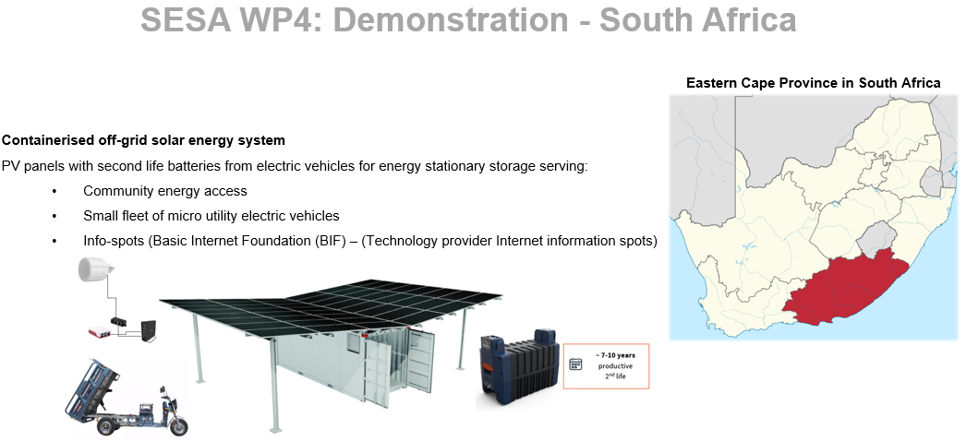Figure 4: Representation of the containerised off-grid solar energy system
The key participants involved in the Living Lab in Alicedale are outlined in more detail in the table below.
Table 7: Key Living Lab participants in South Africa and their roles
Participant | Role and information about the participant
Alicedale Community | Use of technology
Shamwari Community Trust | Civil society representation of community
Nelson Mandela University – uYilo | Local Demonstrator
Local SME’s | Develop and maintain energy projects

3.4.3. Present and future capacity for Sustainable Energy Development
The present and future (desired) capacity required for containerised energy via PV panels and second-life EV batteries in Alicedale, South Africa, is explored in this section.

3.4.3.1. Political and legal capacity
In terms of influencing renewable energy implementation and management, there are several key public and private sector players who form a vital part of the energy landscape in South Africa. Some of the key players include:
- Department of Mineral Resources and Energy (DMRE)
- National Energy Regulator of South Africa (NERSA)
- The South African Photovoltaic Industry Association (SAPVIA)
- Association of Municipal Electricity Utilities (AMEU)
- Eskom
In addition, various policies, strategies and plans are worth highlighting. The Integrated Resource Plan (IRP) is a development plan for new-build electricity infrastructure. It aims to achieve the least-cost electricity supply and meet the energy demand of South Africans, in accordance with the National Development Plan (2030), whilst meeting the climate change objectives of the country. At its core, it sets out what technology should be constructed, the power capacity of the technology and the year in which it should be commissioned. Further, all electricity infrastructure is required to fall within this plan for review by the public and provincial and national governments.
In 2019 the Department of Energy (now the Department of Mineral Resources and Energy) published the most recent version of the IRP (Department of Mineral Resources and Energy, 2019) . For the first time, embedded generation (also referred to as distributed generation) was assigned annual capacity. This was due to multiple requests from companies, municipalities and individuals interested in starting their own projects. Up to 500MW of annual capacity has now been allocated to embedded generation up to 2030.
Further, in April 2021, a licensing exemption and registration notice was released (Department of Mineral Resources and Energy, 2021) . The notice is relevant for all embedded generation systems under 100MW. Previously, systems over 1MW in size were required to obtain a generation licence. The exemption notices now specify that:
- Embedded generator (EG) systems with a capacity of up to 100KW do not require registration or licensing from the regulator (NERSA). Registration is required with the distributor, as well as compliance with the respective point of connection conditions.
- EG systems with a capacity of up to 100MW are exempt from holding a generation licence but require registration with the regulator. Relevant grid code compliance is needed.
Given these two policy amendments, the policy and regulation landscape provide an enabling platform for the technologies used in the SESA Living Lab to be developed.

3.4.3.2. Economic and social capacity
Knowledge and awareness: While the national grid is unreliable in South Africa, with many communities – including Alicedale – experiencing blackouts, there is simultaneously little to no sustainable energy infrastructure currently operating in Alicedale (for several reasons) because there is a lack of information and low awareness about renewable energy solutions and the benefits thereof. However, the consensus is that the community is open to introducing solar and e-mobility. Further, it was noted that community buy-in is crucial for the Living Lab to overcome challenges.
Human capacity and skills: As noted in the Implementation Plan, no renewable energy systems are operating within Alicedale, and only a few systems are operating in the surrounding areas. Thus, the local community have had little to no exposure to solar PVs, battery systems and EVs as alternative sources of energy and mobility, nor the installation, maintenance and business opportunities of these technologies. However, some people in the community have basic mechanical understanding and skills.
Access to finance: Cycles of poverty impede the local communities' ability to access, trial and expand renewable energies. The barrier to access is intensified by the fact that no grants or financial support are available for the energy technology being piloted. Furthermore, there is no sufficient business model for solar PV and second-life EV battery energy.

3.4.4. Gaps between present capacity and future desired skills

3.4.4.1. Political and legal capacity gaps
As outlined above, several policies, plans, and institutional arrangements guide renewable energy in South Africa. According to the Implementation Plan, the main challenges are less around policy gaps than funding and capacity development to implement policy.

3.4.4.2. Economic and social capacity gaps
Knowledge and awareness: There is a lack of information and education or training in Alicedale to spread awareness about accessing and using renewable energy solutions and the benefits of such technologies. To overcome this challenge, workshops, dialogues, community meetings and awareness campaigns are highly useful for improving community knowledge. In addition, word of mouth is a key way in which the community comes to learn about and accept new technologies.
Human capacity and skills: Exposure to and experience working with solar PVs, battery systems and EVs as alternative energy sources is critical under SESA to equip the community with experience and understanding of how the technologies can be installed, operated, maintained and utilised effectively. While, to date, there have been little to no renewable energy initiatives within the community, and there has been a lack of information on operating renewable technologies, there are people in the community with some basic mechanical understanding and skills. It was noted during stakeholder consultations that in-person training and demonstrations will be an important means of upskilling users and innovators. Through stakeholder engagement, it was found that skillsets for development include driving and maintenance operation. Involving youth was noted as an important target audience for the e-mobility context.
Access to finance: Insufficient mechanisms to access funding leaves a gap and opportunity for the development of requisite financial mechanisms to support access to solar PV and battery-provisioned energy. There is a need to improve entrepreneurial skills, including knowledge, to access finance for renewable initiatives.

3.4.5. Tools to fill capacity gaps
Below are a variety of possible tools that could be implemented in South Africa to assist in addressing some of the capacity gaps in relation to sustainable energy development:
- Development of communications materials to explain climate change and its impacts in the African context in an easy-to-understand and visual manner. Development of communications products showcasing the benefits of renewable energy technologies in urban Africa.
- Development of communications products showcasing the benefits of renewable energy technologies in urban Africa.
- Development of communications products briefly explaining the site-specific technologies (what they are and their benefits) in Alicedale in a visual and easy-to-understand manner.
- Explaining the site-specific technologies' maintenance aspects to a user through communications products or trained community members. If members of the community are a suitable option, a train-the-trainer approach will be needed to ensure the selected maintenance members are aware of all the relevant maintenance information.
- Supportive e-learning media, including video, animation and online tutorials for users of solar energy systems and electric mobility. Video and animation media is a popular means of delivering knowledge in a way that is understandable, practical and easy to remember. E-mobility and entrepreneurship were noted as important areas to include. Developing the video content in a gender-responsive way was also noted as an important factor to consider during the conceptualisation phase.
- In-person training and workshops on installation, operation, maintenance and use of technology with users to allow for transference of skills and a space for users to ask questions and raise concerns. It is strongly advised that efforts focus more on in-person delivery. House-to-house visits may be useful to invite the community.
- Community users training on electricity, solar PV, and battery provisioned energy, especially for powering EVs.
- User-Manuals and guidelines for the community in the local language.
- Online training on installation, operation, maintenance and use of technology with innovators and users. While online media is useful for referral purposes, it cannot be the primary means of delivering knowledge and training due to limited access to the internet in the community.
- Online workshops on financial mechanisms and tools for respective technologies
- Training on suitable appliances and infrastructure for relevant technology
- Introductory training on EVs and related infrastructure
- Radio broadcasting on information on the Living Lab, the technology and opportunities
- Expansion of entrepreneurship programme to include sustainable 1) agriculture, 2) tourism and 3u) transportation business models.
- Computer training, including basic website design (and any equipment and stationary necessary as identified by the Living Lab)
- Driving training for micro utility EVs.
CARE Alicedale and Shamwari Community Trust are the key partners offering crucial space for the facilitation of training and demonstration. In addition, high schools and churches were also noted as potential community centres for awareness-raising. eNtsa, an engagement unit based at Nelson Mandela University (NMU), and uYilo are well positioned to lead the training and technical assistance aspects.
Study findings again highlight the importance of language when it comes to capacity-building tools. The home language composition for Alicedale is as follows: isiXhosa 70 percent, Afrikaans 20 percent, and English 10 percent. However, 50 percent of the audience whose home language is isiXhosa or Afrikaans are comfortable communicating in English, and 100 percent of the audience can understand English though they may prefer to respond in their home language. For this reason, communications should focus primarily on English and isiXhosa.

3.4.6. Summary of results
A summary of the results is provided in Table 8 below.
Table 8: Summary of results for South Africa
Thematic area | Present capacity of relevant on Sustainable Energy Development | Future capacity (desired state) based on the city’s vision for the Sustainable Energy Use | Gaps between present capacity and future desired skills | Tools and training modules to fill these gaps
Political and legal | Strong enabling environment created through national and local government policy  No regulations/standards on the use of second-life EV batteries | Supportive policy and programmes for sustainable energy technology for electrification and EVs  Mainstreaming of sustainable energy technology in national and local government infrastructure planning  Regulations on second-life batteries and their usage | Development of policy on sustainable energy technology or electrification  Introduction to EVs and training on how the technology works as well as the potential benefits  Policy and planning mechanisms that can support these technologies at the local level  Development of second-life EV regulations | Online capacity-building workshops on ways in which to further support sustainable energy and electric vehicles (such as support programmes, subsidies etc.)  Case study information/technical support on regulations on EVs and second-life battery usage
Knowledge and awareness | Little information about respective sustainable energy and sustainability | Understanding of sustainable energy and the benefits thereof | Community knowledge on renewables operation, maintenance and benefits improved | Awareness-raising/ capacity building/roadshows/infographics on sustainable energy technology and the associated impacts
Human capacity and skills of community | Unfamiliar with using solar PVs, battery systems and EVs | Able to use for daily activities | Community gains experience and understanding of how technology works  Community gains experience and understanding on how technology can be used for current activities  Community gains experience and understanding on how to operate and, to a certain extent, maintain technology  Community gains understanding of the benefits of the technology and potential opportunities | Introductory training to EVs and related infrastructure  In-person demonstrations and training for the community in local languages  Driving training for micro utility EVs
Skills of local innovators | A high level of skill within urban centres in South Africa to design, implement and maintain renewable technologies  Low level of skills within rural areas including Alicedale  Little experience with second-life battery and its uses  Little history of rural EV market in South Africa | A high level of skill within rural areas for respective technologies  Understanding of second-life batteries and their functioning  EVs are commonly used within rural setting for transport | Rural local innovators gain understanding and experience with relevant technologies  Demonstration of second-life EV battery usage | In-person training on technologies  Site visits to companies where technologies are used  Incubation and mentoring of companies  Pilot projects and monitoring of second life EV battery usage  Computer training including basic website design
Finance | No grants or subsidies given directly for sustainable energy technologies being piloted  Existing business model of providing energy access through solar PV and batteries | Supportive grants and subsidies | Development of supportive financial mechanisms for respective technologies | Online workshops on financial mechanisms and tools for respective technologies  Learning session(s) for Living Labs and/or local innovators unpacking the basics around small business development in relation to sustainable energy technologies  Expansion of entrepreneurship programme to include sustainable: 1) agriculture, 2) tourism (including catering, restaurant, tours, clothing, beading, accommodation), and 3) transportation (shared vehicles) business models

3.5. Morocco

3.5.1. Country context and background
Morocco is a northwest African country bordering the Atlantic and Mediterranean oceans. Morocco acted as a host of COP7 in 2001, where the Marrakech Agreement was reached, and the COP22 in 2016 in Marrakech. More recently, Morocco acted as a powerful advocate for Africa at COP23 in Bonn and COP24 in Katowice. Notably, COP22 marked Morocco’s increasing presence in the global arena, its leadership in the deployment of clean energy technologies, and its role as an advocate for Africa and for least developed countries. Conscious of the magnitude of challenges the African continent faces, Morocco is now pursuing several cooperation initiatives, including creating excellence centres to serve African countries in the energy and climate fields (International Energy Agency, 2019).
Morocco has made impressive progress in electrification. According to the International Energy Agency (2019), Morocco’s population has full access to electricity, a key pillar of Sustainable Development Goal 7 on energy. Morocco is also leading the deployment of renewable energy in North Africa and the Mediterranean with an impressive track record in developing solar technologies, most notably concentrating solar power (CSP) and hybrid technologies with solar PV at the world’s largest CSP park in Ouarzazate. Morocco has increased the hours of storage in its CSP plants and is investing in new interconnections and market integration with European neighbours, thus ensuring greater security, efficiency and flexibility of the power system. Morocco is pursuing an ambitious energy transition pathway. More investments will be needed from both the private and public sectors to meet its renewable and energy efficiency targets (Internal Energy Agency, 2019).
In Morocco, the transport sector consumes 38 percent of energy and represents the country's second-largest CO2 emitting sector. Aware of the continued growth in the motorisation rate, Morocco is now accelerating its energy transition to avoid future issues, which are often difficult and costly. Morocco's electrical mobility is considered a fundamental aspect of its energy transition. While the number of electric vehicles in Morocco reached only 0.01 percent of the global market in 2017, Morocco, through the Ministry of Energy, Mines and Sustainable Development, adopted a National Strategy for Sustainable Development, incorporating sustainable mobility.

3.5.2. Actions planned for Living Lab
The Living Lab in Marrakesh will use solar PV at the rural demonstration site and lithium-ion batteries at the urban demonstration site to foster renewable energies and electric mobility, taking a circular economic perspective at the core of the approach. The choice of the validation sites for the project’s activities follows the same vision of the Moroccan electrification program and aims to boost the economic development in rural areas by promoting the creation and modernisation of income-generating activities through the energy transition and the integration of off-grid solar energy systems. The targeted rural sites in Marrakech are divided into two major categories: schools and households. With the help of the Act4Community association –whose main objective is to improve the standard of living of the rural populations significantly, sustainably, and concretely – 13 households and seven schools based in six different rural villages, all in the ecosystem of the phosphate mines of Ben Guerir and Bouchane, have been chosen. The selection criteria were mainly social, as the households experience a lack of the main vital services such as electricity, drinking water, heating, cooking and sanitation. Another selection criterion was the proximity to the ecosystem of Green Energy Park and its Living Labs. The villages are within five to 20 kilometres of the research centre. The urban site will establish charging facilities for electric scooter transportation at a boarding house (The association for the education of young rural girls) in Marrakech that aims to empower underprivileged girls from rural Morocco to access quality education. The project’s participants include the Blekinge Institute of Technology (BTH) (coordination, expertise in urban planning); University Cadi Ayyad (IMED-Lab) (expertise in renewable energies, electrochemical Energy Storage – lithium-ion batteries (LiBs), electric mobility, thermal energy storage, eco-building); Green Energy Park (Industry/SME provision of the Green & Smart Building Park platform and staff); and National School of Architecture Marrakech (ENAM) (expertise in building materials and techniques).
The key participants involved in the Living Lab in Marrakech are outlined in more detail in the table below.
Table 9: Key Living Lab participants in Morocco and their roles
Participant | Role and information about the participant
Blekinge Institute of Technology (BTH) | Coordination, expertise in urban planning: The Swedish School of Planning/Department of Spatial Planning, is one of the departments at BTH. The department will coordinate the work on the demonstration case of Marrakech, which includes a demonstration of rural energy and environmentally efficient housing, and the transition toward solar energy for urban mobility. Together with the University Cadi Ayyad (UCA), Green Energy Park (GEP) and National School of Architecture (ENAM) the Swedish School of Planning – the Department of Spatial Planning will engage in the transition to solar energy-based urban mobility and in the development of integrated rural ecological and solar energy off-grid housing units.
University Cadi Ayyad (IMED-Lab) | Expertise in renewable energies, electrochemical Energy Storage –LiBs, electric mobility, thermal energy storage, eco-building.
Green Energy Park | Industry/small-to-medium enterprise provision of the Green & Smart Building Park platform and staff: Green Energy Park (GEP), the first platform of its kind in Africa, is leading the trend in applied research to develop reliable decarbonised energy systems and conduct more innovative projects that bring solutions relative to the integration of the renewables in our global energy system and the sustainable natural resource management, which oversees modal shift towards sustainable systems. Also, the breakthrough complementary platform GREEN & SMART BUILDING PARK (GSBP), the GEP-affiliated platform is dedicated to the research and development in green buildings, sustainable development, circular economy, energy efficiency, electrical mobility, and micro and smart grids. The aim is to enhance the shift towards a more sustainable and resilient environment in Morocco, provide advanced equipment to support innovation and research and ensure capacity-building contributions.
National School of Architecture Marrakech (ENAM) | Expertise in building materials and techniques

3.5.3. Present and future capacity on Sustainable Energy Development
The following section unpacks several key aspects of capacity – both present and future (desired) capacity – required for a circular economy of PV and lithium-ion batteries and e-mobility in Marrakech, Morocco.

3.5.3.1. Political and legal capacity
Several key public and private sector players form a vital part of the energy landscape in Morocco. These are detailed below.

Ministry of Energy, Mines and Environment / Moroccan Ministry of Energy, Mining, and Sustainable Development (Ministère de l'Énergie, des Mines et du Développement Durable, MEMDD)
The Ministry of General Affairs and Governance (MAGG): the administrative authority responsible for price and competition policy in Morocco, which also regulates electricity and fuel prices. Before final approval, the proposed tariffs are reviewed by an interministerial tariff committee that includes the Ministry of Economy and Finance and the MEMDD.
Ministry of Economy and Finance: oversees the financial side of the energy sector. It approves the investment plans of state-owned utility ONEE (National Office of Electricity and Drinking Water) and other state-owned entities.
The Ministry of Industry, Investment, Trade and Digital Economy: is indirectly involved in the implementation of energy policy, as the Ministry 1) designs and implements industrial strategies (i.e., through local content components) and 2) works to enhance the competitiveness of Moroccan industry, including through efficiency.
National Office of Electricity and Drinking Water (Office National de l’Électricité et de l’Eau Potable) (ONEE): state-owned vertically integrated utility that owns the transmission network and generation assets. It acts as a single buyer of electricity generated by other parties; it imports electricity and is responsible for electricity distribution (either directly or through private and public distribution companies). The planned restructuring and unbundling of ONEE is ongoing, and ONEE has to transfer its renewable energy assets to the newly created Moroccan Agency for Sustainable Energy (MASEN).
The National Agency for Energy Efficiency (Agence marocaine pour l’efficacité énergétique, AMEE): in charge of implementing Morocco’s energy efficiency policy. In 2016, it replaced the previous National Agency for Renewable Energies and Energy Efficiency (ADEREE), the successor of the Center for the Development of Renewable Energy in 2010.

National Federation of Electricity and Renewable Energies (FENELEC)
Research Institute for Solar Energy and New Energies (Institut de Recherche en Énergie Solaire et Énergies Nouvelles, IRESEN): was created in 2011 as one of the main research, development and innovation bodies for energy. IRESEN is responsible for identifying research priorities and projects in renewable energy and energy efficiency. In addition to financing and implementing research and development projects, it also disseminates research findings and promotes their effective use by businesses.
Moroccan Agency for Sustainable Energy (MASEN): a limited company with public shareholders responsible for leading and managing the deployment of renewable energy. MASEN develops integrated projects at the technical, economic and financial levels, and coordinates activities through a one-stop shop. It was previously responsible only for implementing the national solar power plan, but in 2016 its responsibilities were extended to promoting all renewable energy technologies. MASEN contributes to the emergence of a national renewable energy industry through training and capacity building, local development and industrial integration, preoperational research, development and demonstration (in pre-operational phases) in Morocco’s renewable energy sector, including in Africa and beyond. The mission of MASEN also includes the promotion and development of renewables at the African continental level and beyond.
The National Office of Hydrocarbons and Mines (Office national des hydrocarbures et des mines) (ONHYM): is responsible for managing upstream hydrocarbon resources.

Company for Energy Investments (SIE)
There are several sound mobility and renewable energy-related policies in place. For example, through the MEMDD, Morocco adopted a National Strategy for Sustainable Development by 2030, including the following strategic axes:
  - speeding up the implementation of energy efficiency and transition policies;
  - promoting sustainable mobility;
  - signing a pact on the exemplarity of the state, which includes measures that the administration will undertake, such as the strengthening of the use of hybrid and electric vehicles;
  - establishing a roadmap for Sustainable Mobility in Morocco through The Ministry of Transport and with the support of National and international specialised agencies;
  - implementing charging standards and infrastructure through Morocco, launched by the Ministry of Industry;
  - reducing transport energy consumption by 35 percent in 2030 through The Energy Efficiency 2030 strategy plans; and
  - Setting up an inter-ministerial commission on sustainable mobility under the chairmanship of the head of government.
Other noteworthy policies include:
- Moroccan Climate Change Policy (2014)
- National Energy Efficiency Strategy (2030)
  - Amongst other things, the Energy Efficiency 2030 strategy plans to reduce transport energy consumption by 35 percent in 2030
- National Sustainable Development Strategy

3.5.3.2. Economic and social capacity
Knowledge and awareness: Study findings show a high awareness amongst Green Energy Park stakeholders and some awareness amongst the local population regarding sustainable energy and e-mobility. In urban areas, the population is more open and familiar with renewable energies. In particular, Morocco’s sun exposure is commonly utilised to power solar power systems for water heating and electricity. While some larger-scale commercial farmers in rural areas utilise solar panels to power farm operations such as water pumping and barn heating, renewable energy is less familiar amongst small-scale subsistence rural households. Nevertheless, the target community has been introduced to the technology as there was training conducted in 2019 on solar water pumping systems. Additionally, a key partner found in previous work, that rural communities tend to be very open to introducing renewable systems when the benefits are clear to the community.
With regards to electric scooters in the urban site in Marrakech, the target group are young female university students with little exposure to e-mobility thus far. However, it was noted that they are highly competent learners with an eagerness to understand new things.
A further concern noted by stakeholders is the inadequate understanding of renewable energy amongst journalists and the media, who play a vital role in disseminating information.
Human capacity and skills: While there is some awareness of sustainable energy generally, there are low levels of knowledge and skill to install, utilise and maintain electric vehicle (EV) scooters and second-life battery technology.
For the electric scooters, the women have had some minor exposure to e-mobility through infrequent demonstrations; however, their understanding is slim, and they haven’t had sufficient opportunities to practise using or maintaining the technology.
Similarly, the community of the rural site has demonstrated high levels of interest and desire to learn how to operate and maintain the solar power systems.
Another area identified as needing training to support effective transitions to renewable energy is the local-level government staff involved in energy. It was noted that there is only a medium-level comprehension of renewable energy and its uses among municipal staff. This hinders the government's ability to implement policy into local action plans effectively and is particularly challenging in staff turnover cases.
Access to finance: According to the SESA implementation plan, Morocco has established many boosting financial actions for the deployment of electric vehicles by 1) lowering the import duties to 2.5 percent instead of 17.5 percent, and 2) implementing the exemption for the transport and luxury taxes.
While Morocco has implemented several actions to support EVs, there is a need to develop financial, technical assistance and business models to improve fiscal accessibility to access EVs and second-life batteries.

3.5.4. Gaps between present capacity and future desired skills

3.5.4.1. Political and legal capacity gaps
While there are several policies, plans and institutional arrangements guiding renewable energy in Morocco, as described above, there is still a need to strengthen the enabling environment for enhancing policies and strategies for Morocco's sustainable energy and resilient mobility objectives.

3.5.4.2. Economic and social capacity gaps
Knowledge and awareness: While both groups have had some exposure to solar power systems and electric scooters, the SESA project will need to advance local communities’ understanding of EVs and second-life battery technology and the benefits of these sustainable solutions and opportunities associated with the technology.
For successful and sustainable impact, education and awareness-raising campaigns with the target groups are necessary to develop their knowledge to a high level. This should be achieved through awareness-raising, including events, exhibitions and education campaigns on solar power systems, electric mobility, and second-life battery technologies. More specifically, the content should be user-friendly and easily accessible, unpacking how the technology works, its durability, benefits and multiple opportunities for use.
More broadly, copy media have a knowledge gap in their understanding of renewable energy technologies, which has a knock-on effect on information disseminated to the public. This media gap would benefit from thorough and targeted training for members of the press to improve information on renewable energy available to the public.
Human capacity and skills: Levels of local understanding and skills for installing, utilising and maintaining electric scooters with second-life battery technology require improvement for effective, sustainable transitions in e-mobility in Marrakesh. Furthermore, it has been noted that there is a need to train selected stakeholders/companies on implementing effective e-mobility business models.
More specifically, the women from the target urban site lack the competency to use and maintain the second-hand li-ion battery systems and the electric scooters. They will require training on the use, maintenance, risks and safety. In addition, if the scooter’s power is above 50cc, the women must obtain their driver's licence to comply with Moroccan transport law.
With regards to solar power systems and the rural site, the community is more likely to successfully take up the technology if the positive impact and benefits of utilising off-grid power are emphasised upfront and demonstrations are widely accessible by targeting diverse age groups, facilitation is in local languages, and catering to different technological literacy levels. Regarding awareness of solar PV maintenance, the community has limited technical knowledge. It would need training so that when problems occur, the users don’t necessarily need to call and pay technicians from installation companies to attend to the issue but will be able to address it themselves.
For local level governments in Morocco to effectively integrate national renewable energy ambitions into local action plans, there is a need to establish comprehensive and targeted training on mainstreaming renewable technology. This training should cover administrative as well as technical aspects.
Access to finance: While finance was not highlighted strongly as a key barrier to access to renewable technologies, it has been noted that the success of systems depends on sustainable business models and small charge fees where appropriate to support responsible use and initiative by users and to ensure any external periodic maintenance costs can be covered.

3.5.5. Tools to fill capacity gaps
It is suggested that a combination of methods for capacity building be undertaken. These include:
- Development of communications materials to explain climate change and its impacts in the African context in an easy-to-understand and visual manner. Development of communications products showcasing the benefits of renewable energy technologies in urban Africa.
- Development of communications products showcasing the benefits of renewable energy technologies in urban Africa.
- Institutional training and awareness-raising to support energy efficiency, solar power and resilient mobility at the local scale and across sectors.
- Awareness-raising through events, exhibitions and education campaigns on solar PVs, EVs and second-life battery technology, benefits and opportunities.
- Community- and user-level training and workshops on solar power systems, electric scooters and second-life battery technology, benefits and utilisation.
- User manuals on solar PV systems and electric scooters, and second-hand batteries developed for users.
- Supportive e-learning media, including video, animation and online tutorials for users of solar energy systems and electric mobility.
- Innovator training and workshops on solar PV systems, electric scooters and second-life battery technology, mechanics and repairs.
- Innovator training modules developed for workshop training.
- Awareness-raising and technical assistance to financial institutions and individuals to increase access to finance for renewable energy solar power systems.
Further information on key considerations for training, capacity and skills-building activities are provided below. This information has been used to develop a summary of training opportunities from partner projects and initiatives.
Similar to the other SESA countries, a key factor to consider when developing capacity-building material in Morocco is what language should be used. Moroccan Arabic and French are the main spoken languages in the country. It was strongly suggested that Moroccan Arabic be used for the rural site while French was useful for the urban site.
In-person engagements are critical as they allow for questions and engagement beyond transmissive messaging. Video, animation and module training support training and awareness-raising but are not ideal as a primary mode of instruction.
To determine times for in-person training and workshops for the urban site, the boarding house director should be consulted as she has all the women schedules. Community representatives should be consulted for the rural site to determine a suitable time for the engagements.
Furthermore, it is suggested that target beneficiaries are consulted to get their insights and expectations about the training to confirm their needs are covered before training and workshops commence.
The Green Energy Park (GEP) is ideal for conducting training as there are many experts and sufficient spaces and materials for facilitating engagements. In addition, the Innovation Centre at Cadi Ayyad University also has an established ecosystem for training spaces where engagements could be hosted.

3.5.6. Summary of results
A summary of the results is provided in the table below:
Table 10: Summary of results for Morocco
Thematic area | Present capacity of relevant stakeholders on Sustainable Energy Development | Future capacity (desired state) based on the city’s vision for the Sustainable Energy Use | Gaps between present capacity and future desired skills | Tools and training modules to fill these gaps
Political and legal | Several policies and strategies are in existence relating to energy and Morocco's goals for energy efficiency and resilient mobility | Strengthened environment for enhancing policies and strategies relating to Morocco's goals for energy efficiency and resilient mobility | Development of enabling environment | Institutional training and awareness-raising to support energy efficiency and resilient mobility at different scales and across sectors
Knowledge and awareness | High level of awareness amongst Green Energy Park stakeholders  Some level of awareness amongst household and school stakeholders  Mixed understanding of renewable energy amongst journalists and the media | High level of awareness through events, training modules and education campaigns on solar, electric mobility and second-life battery technology, benefits and opportunities  High level of understanding amongst journalists reporting on renewable energy | Development of education and awareness on solar, electric mobility and second-life battery technology  Develop press media’s knowledge of renewable technologies | Awareness-raising through events, exhibitions, education campaigns and explainers videos on solar, electric mobility and second-life battery technology, benefits and opportunities targeting national and local government, community stakeholders, and financial institutions  Awareness-raising on climate change causes and impacts on Africa through explainer videos and visual posters  Awareness-raising and training targeting journalists and media on renewable technologies functioning, utilisation, benefits, and opportunities
Human capacity and skills of community | Low level of community understanding and skill related to solar, electric mobility and second-life battery technology | High level of community skills on solar, electric mobility and second-life battery technology, benefits and utilisation | Development of solar, electric mobility and second-life battery technology understanding and utilisation | Training on solar, electric mobility and second-life battery technology, benefits and utilisation through in-person demonstrations, community user training and/or ToT trained members of the community  User manuals developed for community users  Dialogues and/or training sessions on monitoring and evaluating processes for renewable energy technology projects being implemented at the local level
Skills of local innovators | Low levels of understanding and skills relating to business models for solar and electric mobility | High level of innovator skills on business operations for solar, electric mobility and second-life battery technology, mechanics and repairs | Develop training for companies and small business stakeholders on implementing a solar and electric mobility business model | Innovator training and workshops on solar, electric mobility and second-life battery technology, mechanics and repairs  Innovator training modules developed for workshop training
Access to finance | Several actions in place to support access to solar and electric mobility including significantly reducing import taxes and removing the transport and luxury tax on EVs | Improved conditions to access finance for solar, electric mobility and second-life batteries | Develop financial instruments and technical assistance to improve fiscal accessibility | Awareness-raising and technical assistance to financial institutions and individuals to increase access to finance for solar, electric mobility and second-life batteries  Learning session(s) for Living Labs and/or local innovators unpacking the basics around small business development in relation to sustainable energy technologies
Infrastructure | Partial access to materials required for solar and electric mobility and second-life battery operations  Lack of suitable infrastructure in local transport network for EVS  Lack of off-grid networks  Lack of training, diagnostic and test facilities and protocols on LiB end-of-life management | Increased access to materials required for EVs and second-life battery operations  Local transport network infrastructure is suitable for EVS  Off-grid network (PV panels, LiBs), one housing unit model  Training, diagnostic and test facilities and protocols on LiB end-of-life management | Develop capacity of local innovators to safely manage end-of-life batteries | Training materials required for EVs, second-life battery operations and end-of-life management

4. Summary of capacity-building tools
Following extensive qualitative research undertaken in Kenya, Malawi, Ghana, Morocco and South Africa, this Capacity Building Plan identified and showcased various capacity-building tools for the countries that can be explored to address capacity gaps found in relation to sustainable energy technology. The table below highlights all the various tools outlined in the previous section to streamline the information for SESA project partners and other interested parties intending to take the suggested tools forward or explore related thematic areas.
Table 11: Summary of SESA Capacity-Building Tool
Areas | Capacity building topic | Description | Target country | Target stakeholder(s) | Format | Language | Notes | Work package
Policy and legislation | Renewable energy policy development session | Relevant renewable energy policy development showcasing approaches for effective integration of relevant renewable energy technology components into laws and regulations. This can also include revised development plans for target counties | Kenya | National and county government officials (especially energy departments) | In-person training/  hybrid training/  e-learning module | English | Suggested that invites be sent through Ministry of Energy and Councillor of Governors in Kenya | WP 6  Task 6.4  Task 6.3 ?  WP 5  Task 5.2
Policy and legislation | Renewable energy licensing dialogue | A dialogue with decision-makers on the relevant renewable energy licensing to unpack and enhance procedures and processes | Kenya | National and county government officials (especially energy departments) | Stakeholder forum/  in-person dialogue/  hybrid dialogue | English | Suggested that invites be sent through Ministry of Energy and Councillor of Governors in Kenya | WP 6  Task 6.4  Task 6.3 ?  WP 5  Task 5.2
Policy and legislation | Resilient energy mainstreaming training | Institutional training and awareness-raising for supporting energy resilience at different scales | Malawi | National and county government officials (especially energy departments) | In-person training/  hybrid training/  e-learning module | English |  | WP 6  Task 6.4  Task 6.3 ?  WP 5  Task 5.2
Policy and legislation | Renewable energy policy strengthening session | Policy review and integration working session with selected national and local authorities | Ghana | National and county government officials (especially energy departments) | In-person training/  hybrid training/  e-learning module | English |  | WP 6  Task 6.4  Task 6.3 ?  WP 5  Task 5.2
Policy and legislation | Renewable energy institutional support | Online capacity-building workshops on ways in which to further support sustainable energy and electric vehicles (such as support programmes, subsidies etc.) | South Africa | National and county government officials (especially energy departments) | In-person training/  hybrid training/  e-learning module | English |  | WP 6  Task 6.4  Task 6.3 ?  WP 5  Task 5.2
Policy and legislation | Renewable energy policy implementation | Institutional training and awareness-raising to support energy efficiency, solar power and resilient mobility at the local scale and across sectors | Morocco | Ben Guerir Municipality | In-person dialogue/in-person training | French  Moroccan-Arabic | Focus on mainstreaming national renewable energy ambitions into local action plans | WP 2  (Task 2.2, Task 2.4 Task 2.5)
Economic and social capacity | The benefits of renewable energy solutions | Communications products and e-learning module to raise awareness and enhance understanding of the benefits and opportunities of the renewable energy technology | Kenya | National and local government officials | E-learning module/ explainer video/  visual poster | English |  | WP 6 (Task 6.2 Task 6.3)  WP 3 ?  WP 2  (Task 2.2 Task 2.4 Task 2.5)
 |  |  |  | SESA Living Labs site stakeholders/ community | E-learning module/  explainer video/  visual poster | English
Economic and social capacity | The benefits of renewable energy solutions |  | Ghana | National and local government officials | E-learning module/  explainer video/  visual poster | English  Twi
 |  |  |  | SESA Living Labs site stakeholders/ community | E-learning module/  explainer video/  visual poster | English
Economic and social capacity | The benefits of renewable energy solutions |  | Malawi | National and local government officials | E-learning module/  explainer video/  visual poster | English  Chichewa  Chitumbuka
 |  |  |  | SESA Living Labs site stakeholders/ community | E-learning module/  explainer video/  visual poster | Chichewa  Chitumbuka | Material should be visually- and audio- based to cater to all levels of literacy
Economic and social capacity | The benefits of renewable energy solutions |  | Morocco | National and local government officials | E-learning module/  explainer video/  visual poster | French Moroccan- Arabic
 |  |  |  | SESA Living Labs site stakeholders/ community | E-learning module/  explainer video/  visual poster | French  (urban site)  Moroccan- Arabic  (rural site) | Material should be visually- and audio- based to cater to all levels of literacy
 |  |  |  | Financial institutions | E-learning modules/  explainer video/ technical assistance and training modules | French Moroccan- Arabic | Technical assistance to support an enabling fiscal environment for renewable energy | WP 3  WP 5 ?
Economic and social capacity | The benefits of renewable energy solutions |  | South Africa | National and local government officials | E-learning module/  explainer video/ technical assistance and training modules | English
 |  |  |  | SESA Living Labs site stakeholders/ community | E-learning module/  explainer video/  visual poster/ radio broadcasting | English  isiXhosa | While online media is useful for referral purposes, it cannot be the primary means of delivering knowledge and training due to limited access to the internet in the community  Radio is a very popular mode of accessing information
Economic and social capacity | Climate change explained | Communication products explaining climate change causes and impacts in Africa | All | SESA Living Labs site stakeholders/ community | Explainer video/  visual poster | English  Twi  Chichewa  Chitumbuka  French  Moroccan-Arabic  Swahili  isiXhosa | Material should be visually- and audio- based to cater to all levels of literacy | WP 6 (Task 6.2 Task 6.3)  WP 2  (Task 2.2 Task 2.4 Task 2.5)
Economic and social capacity | Site specific technology explained | Communications products briefly explaining the site-specific solar PV technologies (what they are and the associated benefits) in Kisumu and Homa Bay in a visual and easy-to-understand manner | Kenya | All stakeholders in Kisumu  -County of Kisumu  - Users | Explainer video | English  Swahili |  | WP 6 (Task 6.2 Task 6.3)  WP 2  (Task 2.2 Task 2.4 Task 2.5)
 |  |  |  | All stakeholders in Homa Bay  - County of Homa Bay  - Users | Explainer video | English
Economic and social capacity | Site specific technology explained | Communications products briefly explaining the site-specific technologies (what they are and the associated benefits) in Ga North and Atwima Nwabiagya in a visual and easy-to-understand manner | Ghana | All stakeholders in Ga North | Explainer video | English  Twi
 |  |  |  | All stakeholders in Atwima Nwabiagya | Explainer video | English  Twi
Economic and social capacity | Site specific technology explained | Communications products briefly explaining the site-specific BioCooker technology (what they are and the associated benefits) in a visual and easy-to-understand manner | Malawi | All stakeholders in Waliranji-Mchinji  - District government  - Users  Sunflower farmers | Explainer video | English Chichewa  Chitumbuka
Economic and social capacity | Site specific technology explained | Awareness-raising communications products briefly explaining the electric scooters and second-life battery technologies (what they are and the benefits of them) | Morocco | All stakeholders urban site, Marrakech | Explainer video | French  Moroccan-Arabic
 |  |  |  | All stakeholders rural site, Ben Guerir | Explainer video | French  Moroccan-Arabic
Economic and social capacity | Site specific technology explained | Communications products explaining the site-specific technologies (what they are and the benefits) in Alicedale in a visual and easy-to-understand manner | South Africa | All stakeholders in Alicedale  -CARE centre staff | Explainer video/ explainer audio clip | English  isiXhosa | Radio is a very popular mode of accessing information
Economic and social capacity | Site specific technology use explained | Explain the site-specific technologies (Solar PVs) to users through communications products or through trained members of the community | Kenya | Technology users | In-person demo/  explainer video/  train-the-trainer workshop(s) | English  Swahili |  | WP 6 (Task 6.2 Task 6.3)  WP 2  (Task 2.2 Task 2.4 Task 2.5)
Economic and social capacity | Site specific technology use explained | Explain the site-specific technologies to users through communications products or through trained members of the community | Ghana | Technology users | In-person demo/  explainer video/  train-the-trainer workshop(s) | English  Twi | Ghana Living Lab aims to develop certificated short-term courses to be run at AAMUSTED with national accreditation
Economic and social capacity | Site specific technology use explained | Explain the site-specific technology (BioCooker) to a user through communications products or through trained members of the community | Malawi | Technology users | In-person demo/  explainer video/  train-the-trainer workshop(s) | Chichewa  Chitumbuka
Economic and social capacity | Site specific technology use explained | Community- and user-level training and workshops to explain the site-specific technologies  (solar power systems, electric scooters and second-life battery technology utilisation) to a user through communications products or through trained members of the community | Morocco | Technology users | In-person demo/  explainer video/  train-the-trainer workshop(s) | French  Moroccan-Arabic | Primary: in-person engagements as they allow for questions and engagement beyond transmissive messaging  Secondary/supportive: video and animation are useful to support training and awareness-raising but is not ideal as a primary mode  Timing of in-person engagement should be determined in consultation with community representatives (rural site) and the boarding house director (urban)  If needed, Green Energy Park (GEP) and the Innovation Centre at Cadi Ayyad University both have training spaces where engagements could be hosted
Economic and social capacity | Site specific technology use explained | Explain the site-specific technologies to users through communications products or through trained members of the community | South Africa | Technology users | In-person demo/  explainer video/  train-the-trainer workshop(s) | English  isiXhosa  Afrikaans | In-person training and workshops on installation, operation, maintenance and use of technology with users to allow for transference of skills and a space for users to ask questions and raise concerns. It is strongly advised that efforts focus more on in-person delivery  CARE Alicedale and Shamwari Community Trust are regarded as the key partners and crucial space for the facilitation of training and demonstration. High schools and churches are additional options  Radio is a very popular mode of accessing information  House-to-house visits may be useful to invite the community to the in-person demonstrations
Economic and social capacity | Site specific technology maintenance explained | Explain the site-specific technologies' maintenance aspects to a user through communications products or through trained members of the community | Kenya | Technology users | In-person demo/  explainer video/  train-the-trainer workshop(s) | English  Swahili |  | WP 6 (Task 6.2 Task 6.3)  WP 2  (Task 2.2 Task 2.4 Task 2.5)
Economic and social capacity | Site specific technology maintenance explained | Explain the site-specific technologies' maintenance aspects to a user through communications products or through trained members of the community | Ghana | Technology users | In-person demo/  explainer video/  train-the-trainer workshop(s) | English  Twi | Ghana Living Lab aims to develop certificated short-term courses to be run at AAMUSTED with national accreditation
Economic and social capacity | Site specific technology maintenance explained | Explain the site-specific technology’s (BioCooker) maintenance aspects to a user through communications products or through trained members of the community | Malawi | Technology users | In-person demo/  explainer video/  train-the-trainer workshop(s) | Chichewa  Chitumbuka
Economic and social capacity | Site specific technology maintenance explained | Community- and user-level training and workshops to explain the site-specific technologies' (solar power systems, electric scooters and second-life battery technology) maintenance aspects to a user through communications products or through trained members of the community | Morocco | Technology users | In-person demo/  explainer video/  train-the-trainer workshop(s)/ user manuals | French  Moroccan Arabic | Primary: in-person engagements as they allow for questions and engagement beyond transmissive messaging  Secondary/supportive: video, animation and user manuals are useful to support training and awareness-raising but is not ideal as a primary mode  Timing of in-person engagement should be determined in consultation with community representatives (rural site) and the boarding house director (urban)  If needed, Green Energy Park (GEP) and the Innovation Centre at Cadi Ayyad University both have training spaces where engagements could be hosted
Economic and social capacity | Site specific technology maintenance explained | Explain the site-specific technology's (Solar PVs) maintenance aspects to a user through communications products or through trained members of the community | South Africa | Technology users | In-person demo/  explainer video/  train-the-trainer workshop(s) | English  isiXhosa  Afrikaans | In-person training and workshops on installation, operation, maintenance and use of technology with users to allow for transference of skills and a space for users to ask questions and raise concerns. It is strongly advised that efforts focus more on in-person delivery  CARE Alicedale and Shamwari Community Trust are regarded as the key partners and crucial space for the facilitation of training and demonstration. High schools and churches are additional options  Radio is a very popular mode of accessing information  House-to-house visits may be useful to invite the community to the in-person demonstrations
Economic and social capacity | Biogas sensitisation | Communications products and/or trainings to raise awareness and enhance understanding of biogas production from both agricultural and human waste | Ghana | Biogas user | In-person demo/  explainer video/  train-the-trainer workshop(s)/ online training module/guidelines | English  Twi | Ghana Living Lab aims to develop certificated short-term courses to be run at AAMUSTED with national accreditation | WP 6 (Task 6.2 Task 6.3)  WP 2  (Task 2.2 Task 2.4 Task 2.5)
Economic and social capacity | Biomass briquette making for BioCookers | Training on new/innovative ways to make biomass briquettes for BioCookers in Waliranji-Mchinji | Malawi | Living Lab and/or BioCooker users | In-person or online training module/guidelines | English  Chichewa  Chitumbuka |  | WP 6 (Task 6.2 Task 6.3)  WP 2  (Task 2.2 Task 2.4 Task 2.5)
Economic and social capacity | Energy technology monitoring and evaluation  dialogue | Dialogues and/or training sessions on monitoring and evaluating processes for renewable energy technology projects being implemented at the local level | Kenya | County (Kisumu and Homa Bay) government | In-person training/  hybrid training/  e-learning module | English | Co-develop with national government (EPRA and MoE) | WP 6 (Task 6.2 Task 6.3)  WP 2  (Task 2.2 Task 2.4 Task 2.5)
Economic and social capacity | Energy technology monitoring and evaluation  dialogue | Training sessions/material to unpack how to effectively monitor and evaluate the impacts (e.g., reduce CO2 emissions) over time and how to communicate this effectively.  Learning session(s) for living labs and/or local innovators unpacking the basics around small business development in relation to sustainable energy technologies | All | Living Lab and local government | In-person training/  hybrid training/  e-learning module | English
Economic and social capacity | Small business development | Learning session(s) for living labs and/or local innovators unpacking the basics around small business development in relation to sustainable energy technologies | All | Living Lab and local innovators | In-person training/  hybrid training | English  French |  | WP 2  (Task 2.2 Task 2.4 Task 2.5)  WP 3
 | Biogas and solar technical training | Training sessions to enhance biogas and solar energy solutions expertise | Ghana | Living lab and Local innovators | In-person training/  hybrid training/  e-learning module | English  Twi | Ghana Living Lab aims to develop certificated short-term courses, undergraduate and postgraduate courses to be run at AAMUSTED with national accreditation
 | Sustainable agriculture, tourism, and transportation training | Expansion of entrepreneurship programme to include sustainable 1) agriculture, 2) tourism, and 3) transportation business models | South Africa | Living Lab and local innovators | In-person training/  hybrid training/  e-learning module | English  isiXhosa  Afrikaans | Entrepreneurship programme for local economies with a focus on the use of solar power systems, batteries and EVs
 | Sustainable end-of-life battery training | Training, diagnostic and test facilities and protocols on LiB end-of-life management | Morocco  and  South Africa | Living Lab and local innovators | In-person training/  hybrid training/  e-learning module | Moroccan-Arabic  French  English  isiXhosa  Afrikaans
 | Thorough and targeted training for members of the press to improve information on renewable energy available to the public | Awareness-raising and training targeting journalists and media on renewable technologies functioning, utilisation, benefits, and opportunities | Morocco | Journalists and news press | In-person training/  hybrid training/  e-learning module | Moroccan-Arabic  French
 | Deforestation explained | Communication products explaining deforestation causes and impacts in Africa and especially Malawi | Malawi | SESA Living Labs site stakeholders/ community | Explainer video/ visual poster | English  Chichewa Chitumbuka | Material should be visually- and audio- based to cater to all levels of literacy

5. Conclusion and recommendations
The Capacity Building Plan indicates the present capacity, desired capacity, capacity gaps, and possible tools to fill these capacity gaps for the SESA Living Lab sites in Kenya, Ghana, Malawi, Morocco and South Africa. The findings for these countries were informed by desktop research, initial Living Lab engagements, interviews, and an interactive focus group discussion in the form of a “kick-off meeting”.
As showcased throughout, the findings suggest various trends and themes in relation to the various countries' capacity gaps, needs and solutions in relation to sustainable energy development. The general thematic areas included: policy and legal gaps that can be addressed to further support the energy solutions being implemented; stakeholders and community knowledge and awareness of the energy solutions being implemented; limited human capacity and technical skills to either use, monitor, service and/or upscale the energy solutions as well as limited access to finance to enhance and/or update sustainable energy solutions in the site areas and countries.
The various capacity gaps and proposed tools outlined in this document can be used to further inform the Capacity Building Programme, contents included in the SESA toolbox, and a variety of other aligning deliverables undertaken through the SESA project. In addition, the findings shed light on the possible building blocks for capacity development in African cities and regions in relation to sustainable energy development.

Reference list
Akrofi, M.M. and Akanbang, B.A.A. (2021). Integrating sustainable energies into local government plans in Ghana. Scientific African, 12, p.e00764. doi:10.1016/j.sciaf.2021.e00764.
Buckland, H., Eales, A., Brown, E., Cloke, J., Blanchard, R., Yona, L., Zalengera, C., Batchelor, S., Sieff, R., Nyirenda, E. and Bayani, E. (2017). Malawi District Energy Officer Blueprint: Recommendations Paper. ResearchGate. [online] Available at: https://www.researchgate.net/publication/321875124_Malawi_District_Energy_Officer_Blueprint_Recommendations_Paper/citation/download.
Community Energy Malawi (2022). About Us. [online] Community Energy Malawi. Available at: https://www.communityenergymalawi.org/ [Accessed 10 Aug. 2022].
Department of Mineral Resources and Energy (2019). Integrated Resource Plan (IRP2019). [online] Available at: http://www.energy.gov.za/IRP/2019/IRP-2019.pdf.
Department of Mineral Resources and Energy (2021). Licensing Exemption and Registration Notice. [online] Available at: https://cisp.cachefly.net/assets/articles/attachments/85157_44482_23-04_minresourcesenergy_(1).pdf.
Energy & Petroleum Regulatory Authority (2021). About Us. [online] Energy and Petroleum Regulatory Authority. Available at: https://www.epra.go.ke/about/.
Energy Commission (2021). Ghana energy statistics. [online] www.energycom.gov.gh. Available at: https://energycom.gov.gh/files/KeyEnergy20StatisticsHandbook2021.pdf.
Ga North Municipal Assembly (2022). Annual Action Plan. [online] GNMA. Available at: http://gnma.gov.gh/annual-action-plan/ [Accessed 10 Aug. 2022].
Ga North Municipal Assembly (n.d.). Departmental Organogram. [online] GNMA. Available at: http://gnma.gov.gh/departmental-organogram/ [Accessed 10 Aug. 2022].
García, I. and Leidreiter, A. (2016). A Roadmap for 100 percent Renewable energy in morocco. [online] Available at: https://www.worldfuturecouncil.org/wp-content/uploads/2016/10/WFC_2016_A-roadmap-for-100RE-in-Morocc_EN.pdf [Accessed 10 Aug. 2022].
Ghana District (2022). Ghana Districts: A repository of all Local Assemblies in Ghana. [online] www.ghanadistricts.com. Available at: https://www.ghanadistricts.com/Home/District/14 [Accessed 10 Aug. 2022].
Government of Malawi (2018). GOVERNMENT OF MALAWI NATIONAL ENERGY POLICY. [online] Available at: https://rise.esmap.org/data/files/library/malawi/Renewable percent20Energy/Supporting percent20Documentation/Malawi_National percent20Energy percent20Policy percent202018.pdf.
International Energy Agency (2022). Data & Statistics - IEA. [online] IEA. Available at: https://www.iea.org/data-and-statistics.
International Energy Agency (2019). ENERGY POLICIES BEYOND IEA COUNTRIES. [online] Available at: https://iea.blob.core.windows.net/assets/138e3195-d0e6-4345-a66c-92ebe4abbeaf/Energy_Policies_beyond_IEA_Countries_Morocco.pdf.
Make It Green (2022). Malawi. [online] Available at: https://makeitgreen.net/project/malawi/.
Ministry of Energy (2022). About Us – Energy. [online] Available at: https://www.energy.gov.mw/company/.
Ministry of Energy (2019). Ghana Renewable Energy Master Plan. [online] Available at: http://www.energycom.gov.gh/files/Renewable-Energy-Masterplan-February-2019.pdf.
Ministry of Environment & Forestry (2021). About Us. [online] Environment.go.ke. Available at: http://www.environment.go.ke/.
Ministry of Finance (2022). Home. [online] www.finance.gov.mw. Available at: https://www.finance.gov.mw/ [Accessed 10 Aug. 2022].
Ministry of Lands and Physical Planning (2022). About us. [online] Ministry of Lands and Physical Planning. Available at: https://lands.go.ke/about-us/.
Ministry of Natural Resources, Energy and Mining (2019). Malawi Sustainable Energy Investment Study. [online] Available at: https://www.un.org/en/unpdf/assets/pdf/PDF-SDG-2017-05 percent20Malawi.pdf.
National Environment Management Authority (2022). National Environment Management Authority (NEMA) - Establishment. [online] www.nema.go.ke. Available at: http://www.nema.go.ke/index.php?option=com_content&view=article&id=1&Itemid=136 [Accessed 10 Aug. 2022].
Nuclear Power & Energy Agency (2022). Home. [online] Nuclear Power and Energy Agency (NuPEA). Available at: https://www.nuclear.co.ke/.
Rural Electrification and Renewable Energy Corporation (2022). About Us. [online] www.rerec.co.ke. Available at: https://www.rerec.co.ke/ [Accessed 10 Aug. 2022].
StatsSA (2011). Census 2011: Main Place: Alicedale. [online] census2011.adrianfrith.com. Available at: https://census2011.adrianfrith.com/place/264005 [Accessed 10 Aug. 2022].
Takase, M., Kipkoech, R. and Essandoh, P.K. (2021). A comprehensive review of energy scenario and sustainable energy in Kenya. Fuel Communications, 7, p.100015. doi:10.1016/j.jfueco.2021.100015.
The Ministry of Devolution (2022). About Us. [online] Devolution. Available at: https://www.devolution.go.ke/ [Accessed 10 Aug. 2022].

***

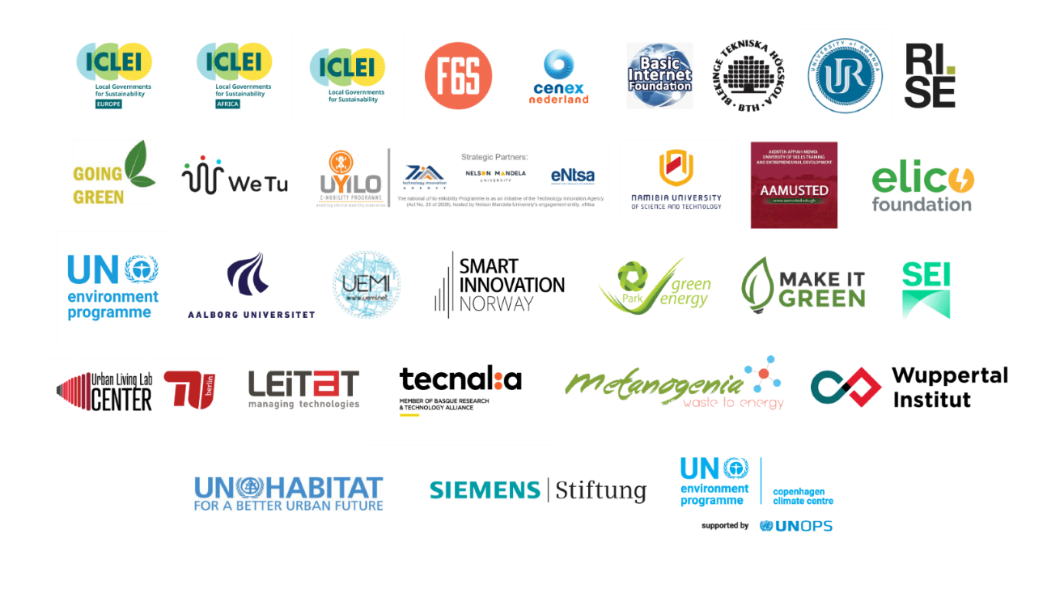
Project partners

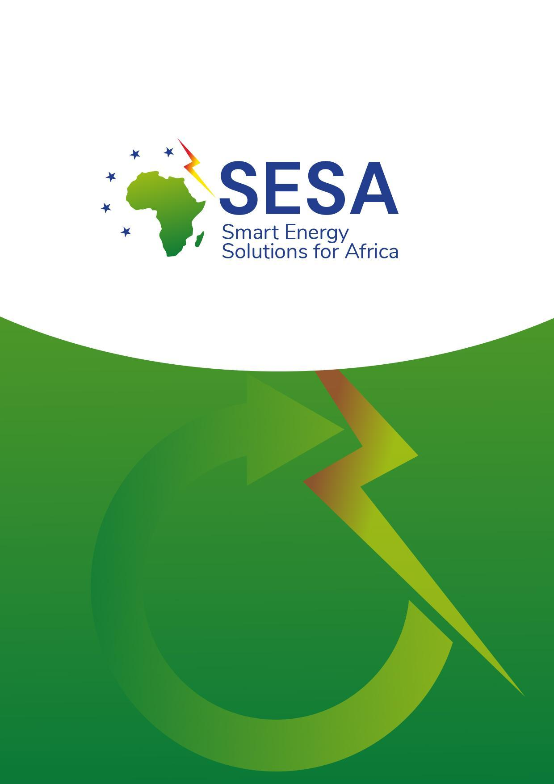
www.sesa-euafrica.eu
contact@sesa-euafrica.com

